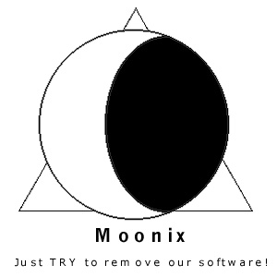

SOFTWARE REQUIREMENTS SPECIFICATION
FOR C-PADT

CSC 205 - 02

March 4, 2002
CREDITS

Cover Page – Moon Yoon

Credits Page – Moon Yoon

Introduction – Brian Wallace

Overall Description – Binh Duong

External Interface Requirements – Brian Wallace

System Features – Brandon McHargue/Jimmy Duong

Nonfunctional Requirements – Jimmy Duong/Moon Yoon

Data Dictionary – Moon Yoon

Appendix A: Glossary – Brandon McHargue

Appendix B: Analysis Models – Jimmy Duong

Appendix C: User Interface – Brandon McHargue

Appendix D: Checklist – Brian Wallace

1. INTRODUCTION 3
1.1 Purpose 3
1.2 Document Conventions 3
1.3 Intended Audience and Reading Suggestions 3
1.4 Product Scope 3
1.5 References 4
2. OVERALL DESCRIPTION 5
3. EXTERNAL INTERFACE REQUIREMENTS 7
3.1 Hardware Interfaces 7
3.2 Software Interfaces 7
4.0 SYSTEM FEATURES 8
4.1 Index of Use Cases 8
5.0 NONFUNCTIONAL REQUIREMENTS 19
5.1 Availability 19
5.2 Maintainability 19
5.3 Recoverability 19
5.4 Resource Consumption 19
5.5 Security 19
5.6 Conceptual integrity 19
5.7 Coding Standards 19
5.8 Thruput 19
6.0 DATA DICTIONARY 20
APPENDIX A: Glossary 22
APPENDIX B: Analysis Models 23
Deployment Diagram 23
Context Diagram 23
Data Flow Diagram 24
APPENDIX C: User Interface 25
APPENDIX D: Checklist 27

1. INTRODUCTION

1.1 Purpose
This document outlines the software requirements for the Cal Poly Automated Degree Tracker (C-PADT), Version 1.0. C-PADT is a Java Graphical User Interface (GUI) application that allows Cal Poly students to access their individual academic records and track the progress towards their degree.

1.2 Document Conventions

The following conventions will be used throughout this document:
- This document will be divided into sections and subsections based on a hierarchical numbering system.
- Section headings will be denoted in all capital letters.
- Sub-section headings will be denoted in normal case and with a section number such as 1.X.
- Detailed sub-sections will be denoted with italics text with a section number such as 1.X.X.

1.3 Intended Audience and Reading Suggestions
This document contains both the customer requirements (Sections 1, 2, 4, 5) and developer requirements (Sections 3, 6) for C-PADT. However, both the customer and developer may want to see and understand both halves of this document. The goal of this document is to condense all project requirements into one agreed upon requirements specification document which may be referenced by both the customer and the developer to ensure that the project is developed and delivered as the customer desires.

Sections 1, 2, 4, 5 and Appendix C are intended for the customer. The intention of these sections is to provide a clear description of the project, outline the purpose of this document, list nonfunctional requirements, and provide a user interface prototype of the application. It is recommended that the customer read these sections in the order they appear in this document to ensure that all functionality is included and that the program appears as they had envisioned.

Sections 3, 6 and Appendix B are intended for the developers of this program. The intention of these sections is to provide a general description of the project, list the program functionality, and outline global implementation details.

1.4 Product Scope
C-PADT is a Java GUI application which will allow Cal Poly students to find academic information regarding their progress towards a degree. C-PADT will allow Cal Poly students to access individual information on completed courses, remaining courses, and graduation requirements to fulfill before a degree in their discipline can be unofficially confirmed.

C-PADT will access student information from a Cal Poly database called PolyData. This will help to ensure that the information provided by C-PADT is identical to the information the Cal Poly State Polytechnic University has on record.
C-PADT will also include administrative functions that will allow administrative users to add and edit information on catalogues, majors, courses, and graduation requires. The administrative functions, however, will not allow the university staff to add or edit individual student information.

The initial version of C-PADT, Version 1.0, will be available to all students enrolled in the Computer Science and Computer Engineering disciplines. Future versions of C-PADT will be made available to Cal Poly students of all disciplines

C-PADT will automate the evaluations process that is currently manually done in the Office of Academic Records. Students will no longer have the need to make an evaluations request with the Office of Academic records; instead, students will use C-PADT to validate student academic degree progress. These evaluations will advise students about major requirements, degree posting, graduation evaluations and other degree related issues.

1.5 References
Information from the following references was used to create the specifications for C-PADT:

Friedman, Marcia A. Records Process Manager, Cal Poly Office of Academic Records, personal interview, January 30, 2002.

Sandy, Linda. Manager, Cal Poly Information Technology Services (ITS), personal interview, February 7, 2002.

Wiegers, Karl E. (1999). Software Requirements. Redmond, Washington: Microsoft Press.

2. OVERALL DESCRIPTION

2.1 Data Flow Diagram
See Appendix B: Analysis Models – Data Flow Diagram.

2.2 User Classes

2.2.1 Cal Poly Student
Cap Poly students will use C-PADT to find out information about their college progress. Students will be able to use C-PADT at any time of the day, except between the hours of 2:00 AM and 6:00 AM.

2.2.2 Administrator
Administrators will consist of C-PADT staffers (Cal Poly ITS workers and student advisors) who will manage each major, its courses, and any errors that may occur. Student information will not be altered by the administrator with an exception to transferred courses. All of the student’s transferred units will be inputted by the administrator personally, into the C-PADT database.

2.3 Operating Environment
The C-PADT program will be implemented in Java, as a GUI using Swing. Every Cal Poly student that wishes to use this program will be given the opportunity to do so. All the student needs is a computer, Internet connection, and a copy of C-PADT installed in the student’s computer. C-PADT will be operated in any OS that supports a windowing system. The C-PADT program will be retrieving information from C-PADT’s database. All of the student’s information will be retrieved from PolyData and copied into C-PADT’s database. Aside from the student’s information, C-PADT’s database will also contain information about courses in a major’s catalogue year (which contain major, support, elective, and GEB courses), graduation requirements, and transferred units.

2.4 System Constraints
The following are constraints to C-PADT:

- C-PADT requires the user to have any type of Internet connection, so that C-PADT can retrieve the student’s information from C-PADT’s database.

- The program installed in the user's computer will be coded in Java. The UI will be a GUI using Swing. The GUI will provide the user with menus where he will be able to choose what he wants to do. By using a GUI, new users will avoid the confusion and learning curve of a command line program.

- The system must be able to retrieve student information from Cal Poly’s database system (PolyData).

- The system will not be able to modify PolyData.

- C-PADT requires 1.5 megabytes of hard drive space.

- C-PADT requires a minimum of 24 megabytes of RAM.

2.5 Assumptions and Dependencies

- On a daily basis, C-PADT will be copying student information from PolyData to its database. If PolyData is nonfunctional, C-PADT will not be able to get daily, updated student information to provide to the student.

3. EXTERNAL INTERFACE REQUIREMENTS

3.1 Hardware Interfaces
See Appendix B: Analysis Models – Deployment Diagram.

3.2 Software Interfaces
To gain access to individual student information, client applications of C-PADT will be communicating directly with the C-PADT server. The C-PADT server will contain an Oracle database which contains a copy of the student academic information stored on Cal Poly’s data warehouse server, PolyData. PolyData is an Oracle database that contains the student information held in the main student information database, SIS Plus. SIS Plus contains a DB2 database and the student academic information it contains is copied to PolyData Monday through Friday between the hours of 7 PM to 7 AM. Between the hours of 2AM and 6AM, Monday through Friday, the C-PADT server will interface with PolyData and copy all relevant student academic information to its own Oracle database.

4.0 SYSTEM FEATURES

The system features for C-PADT consist of Use Cases. This section organizes the functional requirements of our program so that the developers can understand what features must be incorporated into the system.

  - Index of Use Cases

View Major Courses UC-01

View Support Courses UC-02

View General Education and Breadth (GEB) Courses UC-03

View Technical Electives UC-04

View Status of Submitted Technical Electives UC-05

View Graduation Requirements UC-06

View Minor Course UC-07

View Course Description UC-08

View Minor Flowchart UC-09

Calculate Major GPA UC-10

View Cumulative GPA UC-11

Compare Two Flowcharts by Major UC-12

Compare Two Flowcharts by Catalogue Year UC-13

Display Course Prerequisite Chain UC-14

View Transfer Credits UC-15

Add/Edit Course UC-16

Add/Edit New Major UC-17

Add/Edit New Minor UC-18

Add/Edit Graduation Requirements UC-19

Estimate Quarters Left UC-20

Use Case ID UC-01
Use Case Name View Major Courses
Created By Jimmy Duong Last Updated By Jimmy
Date Created 1/25 Date Last Updated 2/23
Actor Student
Description A student can view her major course list for any catalog she is allowed to graduate under. For each major course, C-PADT shows the student's grade. This view includes all technical electives.
The view also includes major course substitutions, deviations, transfer credits and anything else that signifies the completion of major courses.
In case the student is considering retaking a major course, she can edit the grade of any course to view the [possible] effect on major GPA. This change is, of course, temporary and will have no effect on the database.
Preconditions None
Postconditions None
Frequency of Use All the time
Exceptions None
Includes None
Special Requirements None
Assumptions Information on completed and needed courses are correct by the assumption that the information on Cal Poly’s Academic Records is correct.
Notes and Issues None

Use Case ID UC-02
Use Case Name View Support Courses
Created By Jimmy Duong Last Updated By Jimmy
Date Created 1/25 Date Last Updated 2/23
Actor Student
Description The Student can view all his Support courses along with the course units and grade if applicable. Remaining courses will contain blank spaces for their units and grade. Credited courses will contain the letters “CR” for their units and courses.
Preconditions None
Postconditions None
Frequency of Use All the time
Exceptions None
Includes None
Special Requirements None
Assumptions Information on courses and grades are correct by the assumption that the information on Cal Poly’s Academic Records is correct.
Notes and Issues None

Use Case ID UC-03
Use Case Name View General Education and Breadth (GEB) Courses
Created By Jimmy Duong Last Updated By Jimmy
Date Created 1/25 Date Last Updated 2/23
Actor Student
Description The Student can view all his GEB courses along with the course units and grade he earned if applicable. Remaining courses will contain the title of the corresponding GEB Area and blank spaces for the units and grade columns. Credited courses will contain the letters “CR” for their units and courses.
Preconditions None
Postconditions None
Frequency of Use All the time
Exceptions None
Includes None
Special Requirements None
Assumptions Information on completed and needed courses are correct by the assumption that the information on Cal Poly’s Academic Records is correct.
Notes and Issues None

Use Case ID UC-04
Use Case Name View Technical Electives
Created By Jimmy Duong Last Updated By Jimmy
Date Created 1/25 Date Last Updated 2/23
Actor Student
Description The Student can view all the courses that qualify for technical electives in his major. He can find information about his completed technical elective courses and which courses his advisor approved. The Student will view these courses in organized groups, according to their concentrations.
Preconditions None
Postconditions None
Frequency of Use All the time
Exceptions None
Includes UC-05 View Status of Approval of Technical Electives
Special Requirements None
Assumptions None
Notes and Issues None

Use Case ID UC-05
Use Case Name View Approved Technical Electives Lists
Created By Jimmy Duong Last Updated By Jimmy
Date Created 1/25 Date Last Updated 2/23
Actor Student
Description The Student will be able to view all approved technical elective lists which his advisor approves.
Preconditions None
Postconditions None
Frequency of Use All the time
Exceptions None
Includes None
Special Requirements None
Assumptions The Student must submit the approval form in person to his advisor. Students can acquire this form at their advising center. This screen only indicates the list of approved technical elective courses.
Notes and Issues None

Use Case ID UC-06
Use Case Name View Graduation Requirements
Created By Jimmy Duong Last Updated By Jimmy
Date Created 1/25 Date Last Updated 2/22
Actor Student
Description The Student will be able to view all non-course related graduation requirements. This screen includes the GWR, USCP, 2.0 Major GPA, and 60 units of upper division credit.
Preconditions None
Postconditions None
Frequency of Use All the time
Exceptions None
Includes UC-10 Calculate Major GPA
Special Requirements None
Assumptions None
Notes and Issues None

Use Case ID UC-07
Use Case Name View Minor Courses
Created By Jimmy Duong Last Updated By Jimmy
Date Created 1/25 Date Last Updated 2/22
Actor Student
Description The Student can view all his Minor courses along with the course units and grade if applicable. The Student must also meet requirements imposed by the minor’s department such as a minimum GPA of 3.0 on selected courses. The Student can view his track in the minor. Credited courses will contain the letters “CR” for their units and courses.
Preconditions None
Postconditions None
Frequency of Use All the time for Students with Minors
Exceptions None
Includes None
Special Requirements None
Assumptions Information on completed and needed courses are correct by the assumption that the information on Cal Poly’s Academic Records is correct.
Notes and Issues None

Use Case ID UC-08
Use Case Name View Course Description
Created By Jimmy Duong Last Updated By Jimmy
Date Created 1/25 Date Last Updated 2/22
Actor Student
Description The Student will be able to read a brief description of the course that he selects along with the pre-requisites of the course.
Preconditions None
Postconditions None
Frequency of Use All the time
Exceptions None
Includes None
Special Requirements None
Assumptions None
Notes and Issues None

Use Case ID UC-09
Use Case Name View Minor Flowchart
Created By Jimmy Duong Last Updated By Jimmy
Date Created 1/25 Date Last Updated 2/23
Actor Student
Description The Student will be able to view his Minor flowchart. This flowchart will list all the courses that the student needs to take in order to achieve his Minor Degree. Remaining courses will contain blank spaces for their units and grade. Credited courses will contain the letters “CR” for their units and courses.
Preconditions None
Postconditions None
Frequency of Use All the time
Exceptions None
Includes None
Special Requirements None
Assumptions 1. The Student is currently working on a Minor Degree. 2. Information on completed and needed courses are correct by the assumption that the information on Cal Poly’s Academic Records is correct.
Notes and Issues None

Use Case ID UC-10
Use Case Name Calculate Major GPA and Goal Setting
Created By Jimmy Duong Last Updated By Jimmy
Date Created 1/25 Date Last Updated 2/23
Actor Student
Description The Student will be able to view his current major GPA. This page will calculate the current GPA from the list of completed major courses. This feature allows the student to view his current major GPA and also an option to calculate a projected GPA if he were to repeat courses.
There will be a recommendation to repeat any failed courses if his projected GPA is below a 2.00. This function is valuable to students who are contemplating whether to repeat a course.
Preconditions None
Postconditions None
Frequency of Use All the time
Exceptions None
Includes None
Special Requirements None
Assumptions Information on completed and needed courses are correct by the assumption that the information on Cal Poly’s Academic Records is correct.
The student is currently on AP, therefore he would check if his Major GPA is above 2.00.
Notes and Issues None

Use Case ID UC-11
Use Case Name View Cumulative GPA and Goal Setting
Created By Jimmy Duong Last Updated By Jimmy
Date Created 1/25 Date Last Updated 2/23
Actor Student
Description The Student will be able to view his current cumulative GPA. This GPA includes all graded courses, which includes major, support, GE and free electives courses. This feature allows the student to view his current cumulative GPA and also an option to calculate a projected GPA if he were to repeat courses.
There will be a recommendation to repeat any failed courses if his projected GPA is below a 2.00. This function is valuable to students who are contemplating whether to repeat a course.
Preconditions None
Postconditions None
Frequency of Use All the time
Exceptions None
Includes None
Special Requirements None
Assumptions Information on completed and needed courses are correct by the assumption that the information on Cal Poly’s Academic Records is correct.
Notes and Issues None

Use Case ID UC-12
Use Case Name Compare Two Flowcharts by Major
Created By Jimmy Duong Last Updated By Jimmy
Date Created 1/25 Date Last Updated 2/23
Actor Student
Description The Student will be able to compare two flowcharts by different major. The side by side comparison of these two flowcharts allows the student to evaluate his progress against both flowcharts. This is particularly helpful to students interested in switching majors.
Preconditions None
Postconditions None
Frequency of Use All the time
Exceptions None
Includes None
Special Requirements None
Assumptions None
Notes and Issues The first flowchart will be the student’s current flowchart.

Use Case ID UC-13
Use Case Name Compare Two Flowcharts by Catalogue Year
Created By Brandon Last Updated By Jimmy
Date Created 1-28 Date Last Updated 2/23
Actor Student
Description The Student will be able to compare two flowcharts by different catalogue years. The side by side comparison of these two flowcharts allows the student to evaluate his progress against both flowcharts. This is particularly helpful to students interested in switching catalogue years.
Preconditions None
Postconditions None
Frequency of Use All the time
Exceptions None
Includes None
Special Requirements None
Assumptions None
Notes and Issues The first flowchart will be the student’s current flowchart.

Use Case ID UC-14
Use Case Name Display Course Prerequisite Chain
Created By Brandon Last Updated By Jimmy
Date Created 1-28 Date Last Updated 2-24
Actor Student
Description For a given class, the Student can display the chain of prerequisites that must be taken before enrolling in the course. Co-requisites are also displayed within this chain and are equivalent to prerequisites. Co-requisites will be marked with a “C” next to the course to indicate that they are co-requisites.
Preconditions The class must have 1 or more prerequisites.
Postconditions None
Frequency of Use All the time
Exceptions If the chain is broken, then an error message will appear. Reasons for a broken chain:
1. Course number change
2. Deleted courses from flowchart
Includes None
Special Requirements None
Assumptions There are no cycles in the prerequisite chain.
Notes and Issues None

Use Case ID UC-15
Use Case Name View Transfer Credits
Created By Brandon Last Updated By Jimmy
Date Created 1-28 Date Last Updated 2-24
Actor Student
Description The system displays the student’s transfer credits from the following areas: Advanced Placement Credit, College/Junior College Transfer Credit, Military Credit, International Baccalaureate and other transfer credits. Other transfer credits consist of credits not included in the above list such as credit by examination and other methods.
Preconditions None
Postconditions None
Frequency of Use Not often
Exceptions None
Includes None
Special Requirements None
Assumptions Information on transfer credits are correct by the assumption that the information on Cal Poly’s Academic Records is correct.
Notes and Issues None

Use Case ID UC-16
Use Case Name Add/Edit Courses
Created By Brandon Last Updated By Jimmy
Date Created 1-29 Date Last Updated 2-24
Actor Administrator
Description The administrator can modify and edit the courses. He will have control of the displayed information of the course number, course name, units, course description and prerequisites.
Preconditions None
Postconditions 1. The edited flowchart is stored in the database
2. The administrators action is recorded in a log file
Frequency of Use Relatively often
Exceptions None
Includes None
Special Requirements None
Assumptions None
Notes and Issues None

Use Case ID UC-17
Use Case Name Add/Edit New Major
Created By Brandon Last Updated By Jimmy
Date Created 1-28 Date Last Updated 2-24
Actor Administrator
Description The Administrator enters the data for the major and stores it into C-PADT’s database. The data includes all the courses that correspond to the major.
Preconditions None
Postconditions 1. The new major is stored in the database
2. The Administrator’s activity is written to a log file
Frequency of Use Not very often
Exceptions None
Includes None
Special Requirements None
Assumptions None
Notes and Issues None

Use Case ID UC-18
Use Case Name Add/Edit New Minor
Created By Brandon Last Updated By Jimmy
Date Created 1-28 Date Last Updated 2-24
Actor Administrator
Description The Administrator enters the data for the minor and stores it into C-PADT’s database. The data includes all the courses that correspond to the minor.
Preconditions None
Postconditions 1. The new Minor is stored in the database
2. The Administrator’s activity is written to a log file
Frequency of Use Not very often
Exceptions None
Includes None
Special Requirements None
Assumptions None
Notes and Issues None

Use Case ID UC-19
Use Case Name Add/Edit Graduation Requirements
Created By Brandon Last Updated By Jimmy
Date Created 1-28 Date Last Updated 2-24
Actor Administrator
Description The Administrator enters the data for the graduation requirements and stores it into C-PADT’s database. The data includes all the requirements needed to graduate.
Preconditions None
Postconditions 1. The new Graduation Requirements are stored in the database
2. The Administrator’s activity is written to a log file
Frequency of Use Almost never
Exceptions None
Includes None
Special Requirements None
Assumptions None
Notes and Issues None

Use Case ID UC-20
Use Case Name Estimate Quarters Left
Created By Brandon Last Updated By Jimmy
Date Created 1-29 Date Last Updated 2-24
Actor Student
Description The system estimated the number of quarters left for a student to graduate. The system considers the length of the prerequisites chain and the number of units that the student needs to complete. By using these two factors, the system generates the number of quarters left at Cal Poly.
Preconditions None
Postconditions None
Frequency of Use All the time
Exceptions None
Includes None
Special Requirements None
Assumptions Every quarter consists of all courses.
Every quarter consists of configurable number of units.
Notes and Issues None

5.0 NONFUNCTIONAL REQUIREMENTS

Nonfunctional requirements consist of measurable requirements that are not related to the code of the program. Such requirements describe the performance of the system rather than any functions that the system must perform.

5.1 Availability
1. The system will not operate during the hours of 2 AM to 6 AM, Monday through Friday so that C-PADT’s server can update pertinent information from PolyData.

5.2 Maintainability
- A software developer with 6 months experience with Java GUI applications will be able to fix a known bug in the client program in < 2 days given the source codes and the SRS.
- A network administrator with 6 months experience in database management and access to PolyData and the C-PADT server will be able to manually fix a known error the database system in < 1 days.
- A user support person can reconfigure the database structural implementation in < 1 week.

5.3 Recoverability
- No data can be lost from any misuse of the system by a user other than the administrator and all data can be fully recovered since all user data will be stored on the server and up to date data will be retrieved upon login.

5.4 Resource Consumption
- The client program will consume less than 1 Mbytes of memory in the client’s computer.

5.5 Security
- TBD

5.6 Conceptual integrity
- The UI will have conceptual integrity.
- There is consistent program readability: dark fonts on a light background.
- Minimum screen resolution of 640x480 will be met.

5.7 Coding Standards
1. The program will follow Dan Stearn’s coding standards.

5.8 Thruput
1. TBD

6.0 DATA DICTIONARY

Catalog = Year
+ 1:200 {Major}
+ 1:5000 {Course}
+ GEB Requirements
+ Graduation Requirements

Year = * string in the format NNNN-NNNN *

Major = Major Code
+ 1:50 {Major Course}
+ 1:50 {Support Course}
+ 1:50 {GE Course}
+ Flowchart

Major Code = * two to four character string designating a program of study *

Major Course = Course
Support Course = Course
GE Course = Course
Prerequisite Course = Course
Minor Course = Course
Technical Elective Course = Course

Flowchart = * a table of recommended Courses to take each quarter for the given Major. *

Course = Major Code
+ Course Number
+ Course Name
+ Units
+ Course Description
+ 0:5 {Prerequisite Course}

Course Number = * 4-digit integer *
Course Name = * at most 30-character long string *
Units = * integer value *
Course Description = * at most 300-character long string that describes the Course *

GEB Requirements = 1:200 {Course}

Graduation Requirements = GWR
+ USCP
+ Upper Division Units

Student = Login
+ PIN
+ Name
+ 0:100 {Completed Course}
+ Transfer Credits

Login = * string that identifies the user. For Students it will be a 9-digit numerical string and for Administrators it will be a string of characters. *

PIN = * 4-digit integer that confirms the identity of the user. For Students, it is identical to the PIN used by Cal Poly's Mustang Info. *

Name = * Student's name in "Last Name, First Name" form *

Completed Course = Course
+ Grade

Grade = *one or two character string that represents the academic or administrative grading symbol *

Transfer Credits = * list of courses taken at other universities and credits earned by examination *

GPA = * a decimal number ranging between 0 and 4. This is calculated by {[sum of (Units x Numerical Grade)] / sum of Units} *

Numerical Grade = * a decimal number ranging between 0 and 4 corresponding to the letter grade *

Major GPA = GPA
Cumulative GPA = GPA
CPSLO Cumulative GPA = GPA

Administrator = Login
+ PIN

Technical Electives = 1:50 {Technical Elective Course}

Estimate Graduation Date = * 3-digit integer representing quarter and year of expected graduation date in NNQ format *

APPENDIX A: Glossary

C-PADT – Cal Poly Automated Degree Tracker. The name of the system

Mustang Info – The web site run by Cal Poly that keeps track of student information.

MySQL – A type of database. This will be used for the C-PADT database.

PolyData – PolyData is the Cal Poly data warehouse that contains student academic information in an Oracle database. This student information is a copy of the information stored on SIS and is updated daily between 7 PM and 7 AM. This is the database that C-PADT accesses for the student information.

POWER – A web site run by Cal Poly that allows students to register for classes over the internet.

SIS – Student Information System. The database that holds student information.

Swing – A library of Java classes used in the creation of graphical user interfaces.

APPENDIX B: Analysis Models

Deployment Diagram

Context Diagram

Data Flow Diagram

APPENDIX C: User Interface

C-PADT Login Screen

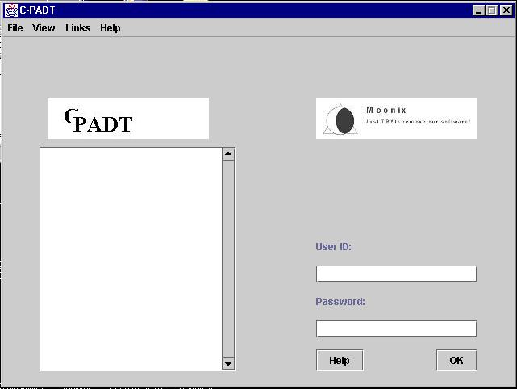

Choose Major and Catalogue Year (Student)

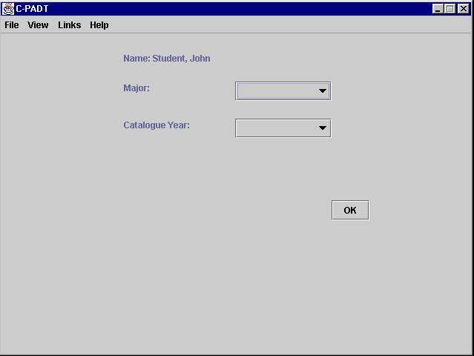

Select Use Cases (Student)

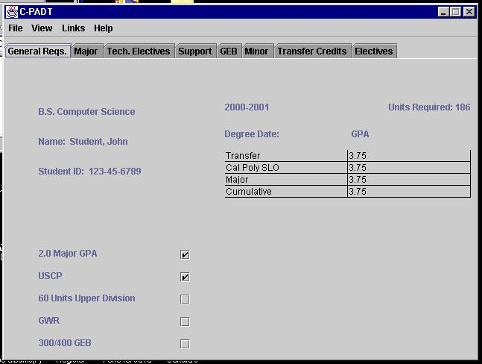

Select Use Case (Student)

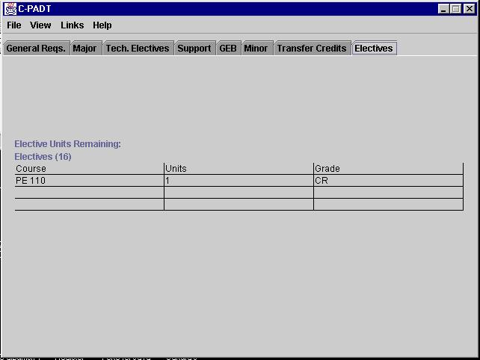

Administrator Welcome Screen

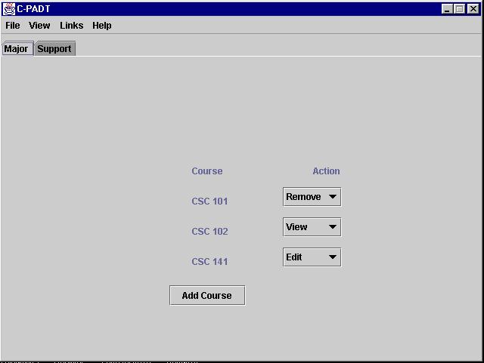

APPENDIX D: Checklist

General
- Cover page contains team logo, 205 section # and date submitted.
- Document has page numbers.
- Document matches the required format.
- Document is of professional quality.
- The credits list is specified clearly, by individual. ("done by team" is explicitly disallowed)
Consistency
- Each non-primitive entity in the data dictionary is used by one or more use cases.
- Every use case noun is in the data dictionary.
- All significant use cases are visible in the prototype.
- All views of the requirements (use cases, prototype, data dictionary) are consistent.
English
- Writing meets the standards of the WPE level 4 or greater.
- All English, including diagram text, is written in the 3rd person using active voice, present tense verbs.
- There are no words from the bad words list.
Problem Domain
- All language is in the problem domain; don't discuss the UI!
(Exception - some non-functional requirements)
- Each view of the requirements (Use Cases, Data Dictionary, Prototype) uses the same problem-domain words.
- There is no discussion of the UI in the SRS.
Non-functional Requirements
- Every requirement is concrete, specific, measurable and testable.
- Every requirement applies to your system.
- There are 3 maintainability requirements.
- The quality attributes list has been explicitly approved by Prof. Stearns.
Data Dictionary
- The data dictionary describes all problem domain entities in the software.
- There are no glossary terms in the Data Dictionary.
- Entries are organized hierarchically and formatted appropriately.
- Every primitive (not decomposed) entity must be used:
in a composite entity
by at least one use case
Use Cases
- The proper format is used.
- Every non-primitive Data Dictionary entity is discussed in one or more use case.
- There is no discussion of the UI in the description.
- There is no textual discussion of Data Dictionary details.
- There are at least 35 use cases in the SRS.
- There are no design domain features described as use cases. Some common non use cases:
  - login/logoff
  - exit system
  - resize window
  - open/close window
- These are system features, not use cases.
Glossary
- Every term is used in the SRS.
- There are no glossary terms in the Data Dictionary.

