Human Computer Interface Design

Chapter 8 –Internet-Based Interactive Systems Design

Objective
Web environments are software-intensive and highly interactive systems. They are becoming more complex, and are inserting themselves in more mission-critical roles. In this lecture, we discuss the following:

- What's hard about designing Internet-based interactive systems (IBIS)?
- State the most important functions that you think a person using an IBIS must be able to do. Who are your users?
- Describe the most important factors influencing the design both from the end users and developers perspectives. What are the usability requirements?

Outlines
- IBIS Taxonomy: Web sites, Intranet Environments, E-Commerce, Internet-Based Systems, Browser-Based User Interface
- Design Guidelines, Usability Factors, Software Architecture and Patterns, Tools
Internet-Based Interactive System (IBIS) Taxonomy
- IBIS Taxonomy includes any software based on (use) the Internet Infrastructure and Technology
- Examples: Web sites, corporate Intranet (employees Web site) and extranet environments (clients Web site)

Web Servers
HTTP
Mail
News

API Client
Others Interface
Mobile Interface
Java-Based Interface
Small Devices Interface

Servers-Based Middleware (Servlets, CGI Scripts, API Server: NSAPI, ISAPI)

Plug-Ins
Viewers
ActiveX Control
Files
Programs
Data
Communicates
Manipulates
Java-Based Middleware
(JDBC, RMI, ORB, GINI, WAP)
Communicates
Manipulates
Communicates
Web Browsers
(Netscape Communicator, Internet Explorer)
Web Browser-based Interface
(HTML… Java Applets)

Utilizes
Communicates

Four levels of IBIS sophistication on the Internet

Web Applications: Characterized by a browser-based user interface, which is a mixture of HTML, DHTML, Cascading style sheets, Java and VB, scripts, Java Applets

- Traditional Web Sites
- Corporate Intranet and Extranet Sites
- Portals
- Portal for corporate Web site Intranet in big and medium company, e-commerce portals
- Establish a single home page for your multiples Web applications.
- Make this page the default-starting page in all browsers distributed within your organization.

- Traditional Web Applications are highly standards-compliant. They will work in two-years with old browsers with no or minimal use of plug-ins or anything else that goes beyond HTML and a few simple images
- The need to stop using Web browsers as the platform for Internet-enabled applications, except when they are targeted purely at casual users. Frequent users will need an optimized interface that takes full advantage of the device they are using.
Embedded Internet services in traditional software tools
- Open URL from FrontPage Explorer
- Display and navigate though links in Adobe Acrobat

Specialized applications that are optimized to provide the best possible user interface to a set of advanced features

- Email provides an example of the interplay between specialized applications and toned-down web applications: it is often possible to access your email through a browser
- Headline Viewer is a Windows application that lets you see news headlines from a configurable list of Headline Providers (news sources and weblogs). Instead of continuously jumping from site to site to check on headlines (and using a big fat browser window), you can let Headline Viewer do it for you (http://www.vertexdev.com/HeadlineViewer)
- Auction Browser: Monitoring a number of ongoing auctions in real timehttp://www.wired.com/news/news/technology/story/20771.html
- GuruNet: pop-up window to retrieve dictionary definitions and other data across the Internet from inside any application (http://www.gurunet.com).

Narrowly focused small devices internet applications that cannot support the full range of features because of a lack of screen space or low bandwidth

- Mobile Telephone Embedded Internet Applications (Read Mail, Browse the Web, etc.)
- Palm Pilot Applications for the Net

This IBIS application will lead to impoverished user interfaces for two reasons:

- A tiny screen cannot show any context, nor can it show menus or visualizations of alternatives
- Small devices push-buttons are poor controls for advanced functionality – as evidence just consider how few of the features on your cell phone you use...

Multiples User Interfaces for an Internet-Based Interactive System

Multiple interfaces should feel like variations of a single system, even though they have different designs:

- All information should be the same across interfaces, even if not all information is shown in all versions. For example, prices should be the same, but a product listing may include only the best-selling items on a small screen with the rest relegated to a secondary "more products" page.
- All user information must be preserved across the interfaces: if I use one access mechanism today and another tomorrow, then the changes I made in one UI are reflected in what I see in the other.
- Unified login, user identification, and user profile (even though not all preference settings may apply to all interfaces, those that do should be respected everywhere so that it is not necessary to manually define such preferences more than once)
- Same functionality and side effects of commands even if certain special features or variations are eliminated in some versions. For example, an airline reservation system may make choosing a flight and buying the ticket two separate steps. This separation should be preserved in all versions instead of having the simplified version unify choosing and buying into a single step.
Multiples User Interfaces for an Internet-Based Interactive System

- It would be OK to have the advanced version include additional features (such as specifying a seating preference) that were not in the simplified version. Missing these features is a trade-off that the user would make in return for the benefits of being able to use the system under various limited circumstances.

- It is not necessary for all features to be found in all access mechanisms. For example, a low-end version may eliminate photos or it may show them in black-and-white. Similarly, text may be abbreviated on a small display, though it should be possible to retrieve the full text through a standardized command.

- It is a major design challenge to decide what features should be preserved in what versions of the system. Graceful degradation can allow users to always have the features that they really need. Achieving this goal will require careful task analysis to determine how users behave when they are on the road or in other functionally limited circumstances.

Web Applications Design: Top Ten Mistakes of Web Design
[Jakob Nielsen's Alertbox, May 30, 1999]

1. Breaking or Slowing Down the Back Button

- The Back button is the lifeline of the Web user and the second-most used navigation feature after following hypertext links). Users happily know that they can try anything on the Web and always be saved by a click or two on Back to return them to familiar territory.

- Except, of course, for those sites that break back by committing one of these design sins:

- Opening a new browser window (see mistake #2)
- Using an immediate redirect: every time the user clicks Back, the browser returns o a page that bounces the user forward to the undesired location
- Prevents caching such that the Back navigation requires a fresh trip to the server; all hypertext navigation should be sub-second and this goes double for backtracking

2. Opening New Browser Windows

- Designers open new browser windows on the theory that it keeps users on their site. But even disregarding the user-hostile message implied in taking over the user's machine, the strategy is self-defeating since it disables the Back button, which is the normal way users return to previous sites.
- Users often don't notice that a new window has opened, especially if they are using a small monitor where the windows are maximized to fill up the screen. So a user who tries to return to the origin will be confused by a grayed out Back button.
- If I want a new window, I will open it myself!

3. Non-Standard Use of GUI Widgets

- Currently, the worst consistency violations on the Web are found in the use of GUI widgets such as radio buttons and checkboxes. The appropriate behavior of these design elements is defined in the Windows UI standard, the Macintosh UI standard, and the Java UI standard.
- Which of these standards to follow depends on the platform used by the majority of your users (good bet: Windows), but it hardly matters for the most basic widgets since all the standards have close-to-identical rules.

- For example, the rules for radio buttons state that they are used to select one among a set of options but that the choice of options does not take effect until the user has confirmed the choice by clicking an OK button. Unfortunately, I have seen many web sites where radio buttons are used as action buttons that have an immediate result when clicked. Such wanton deviations from accepted interface standards make the Web harder to use.

4. Lack of Biographies

- Nielsen studies in 1994 showed that users want to know the people behind information on the Web. In particular, biographies and photographs of the authors help make the Web a less impersonal place and increase trust. Personality and point-of-view often wins over anonymous bits coming over the wire.

5. Lack of Archives

- Old information is often good information and can be useful to readers. Even when new information is more valuable than old information, there is almost always some value to the old stuff, and it is very cheap to keep it online. Nielsen estimates that having archives may add about 10% to the cost of running a site but increase its usefulness by about 50%.

- Archives are also necessary as the only way to eliminate link rot and thus encourage other sites to link to you.

6. Moving Pages to New URLs

- Anytime a page moves, you break any incoming links from other sites. Why hurt the people who send you free customer referrals?

7. Headlines that Make No Sense Out of Context

- Headlines and other micro-content must be written very differently for the Web than for old media: they are actionable items that serve as UI elements and should help users navigate.

- Headlines are often removed from the context of the full page and used in tables of content (e.g., home pages or category pages) and in search engine results. In either case the writing needs to be very plain and meet two goals:
  - Tell users what's at the other end of the link with no guesswork required protect users from following the link if they would not be interested in the destination age (so no teasers - they may work once or twice to drive up traffic, but in the long
  - Run they will make users abandon the site and reduce its credibility)
8. Jumping at the Latest Internet Buzzword

- The web is awash in money and people who proclaim to have found the way to salvation for all the sites that continue to lose money.

- Push, community, chat, free email, 3D site maps, and auctions - you know the drill. But there is no magic bullet. Most Internet buzzwords have some substance and might bring small benefits to those few web sites that can use them appropriately. Most of the time, most web sites will be hurt by implementing the latest buzzword. The opportunity cost is high from focusing attention on a fad instead of spending the time, money, and management bandwidth on improving basic customer service and usability.

9. Slow Server Response Times

- Slow response times are the worst offender against Web usability: in my survey of the original "top-ten" mistakes, major sites had a truly horrifying 84% violation score with respect to the response time rule.
- Bloated graphic design was the original offender in the response time area. Some sites still have too many graphics or too big graphics; or they use applets where plain or Dynamic HTML would have done the trick. So I am not giving up my crusade to minimize download times.

- Users don't care why response times are slow. All they know is that the site doesn't offer good service: slow response times often translate directly into a reduced level of trust and they always cause a loss of traffic as users take their business elsewhere. So invest in a fast server and get a performance expert to review your system architecture and code quality to optimize response times.

10. Anything that Looks Like Advertising

- Selective attention is very powerful, and Web users have learned to stop paying attention to any ads that get in the way of their goal-driven navigation. That's why click-through rates are being cut in half every year and why Web advertisements don't work.

- Unfortunately, users also ignore legitimate design elements that look like prevalent forms of advertising. After all, when you ignore something, you don't study it in detail to find out what it is.

Web Pages Classification

- Web applications are content-oriented interactive pages.
- A content consists of two categories of elements: information-based content and the navigation and browsing mechanisms.

Different pages types

- Home page, which is the central page of your site from which all, other pages can be reached (directly or indirectly).
- Navigation pages for directing the user to the proper area of your site for the information they are seeking.
- Content pages provide the information users are seeking when they visit your site. They may also contain navigational information to give users a sense of location within the site and allow them to progress to more information or return to a previous page.
- Input page (also called a form) is to collect information from, or establish a dialog with, the user.
- Utilities pages (bookmarks, extra things, help, etc.)

Pattern for Home Pages

Good UI Elements

- Utility toolbar including Home, Search, Map site, About this Site, Contact us, Help buttons
- Index of Majors Topics (e.g. products, services, courses, programs, resources, etc.)
- Shortcuts menu (List of pages that are frequently visited)
- Push information sections (What’s New, FAQ, Discussion Groups, Important information, Publicity Banner, etc.)
- Maintenance support information

Bad UI Elements

- Frames (difficult to print and visualize the content), big size images, irrelevant applets (applet for animating images), blinking texts, banners

A Well Designed Home Page (http://www.oclc.org)

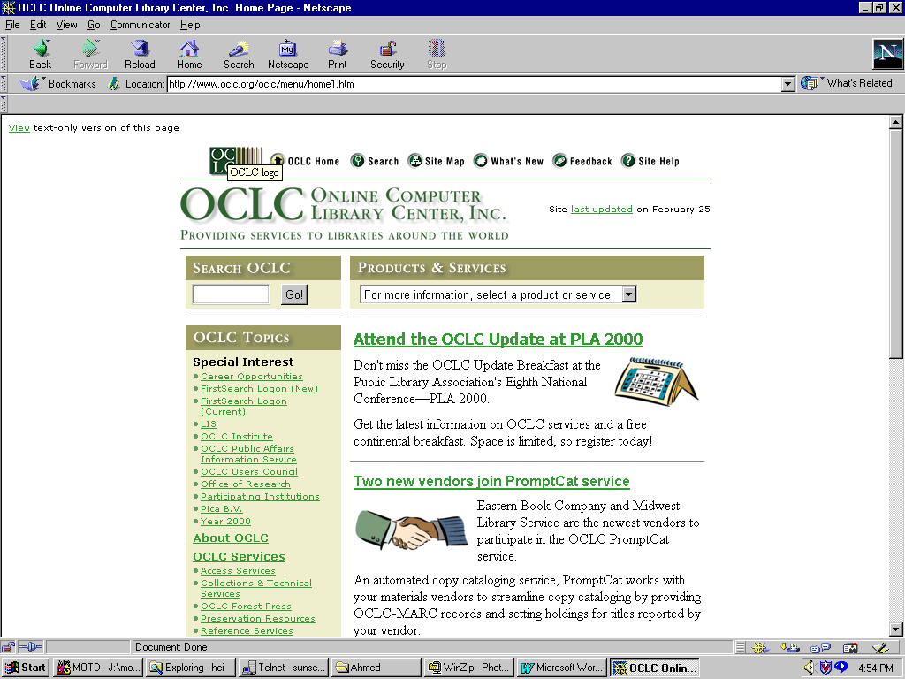
Applying RealThings Design to a Navigation Page

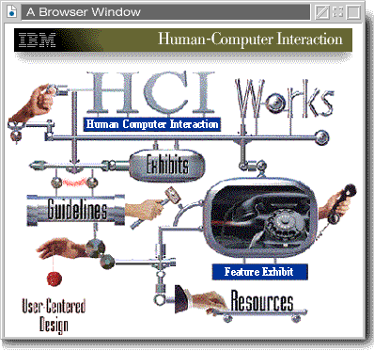

Safe Dimensions for Web page graphics

A Web page can be almost any length, but you've only got about 30 square inches at the top of your Web pages to capture the average reader, because that is all they will see as your page loads. If all you offer is a big, slow-to-load graphic, many casual readers will leave before they ever see the rest of your Web site.

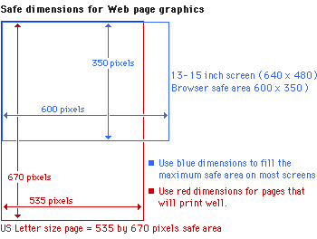
Page Grid for content page including Navigation

Establish a consistent and logical screen layout that allows you to quickly "plug in" text and graphics for each new content page without having to stop and rethink your basic design approach for every new page.

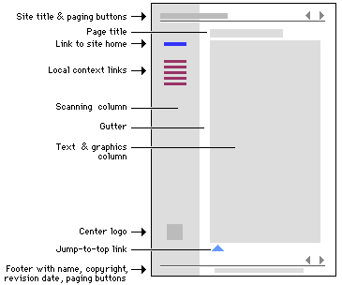 | 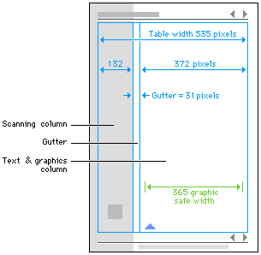

Affordance

- An interface control has affordance when a user can infer its function from its appearance.
- Navigation elements in a web site must provide affordance. Their appearance should help users understand that their purpose is for navigating through the presentation.

- The mouse pointer change provided by web browsers to indicate that the element pointed at is a link is not sufficient. The designer can use differences in size to establish a hierarchy between links, but HTML text has poor graphic quality and doesn't allow much visual characterization.

- The designer will explain what will help users differentiate links from information contents. Differentiation between navigation elements and information is indeed the main affordance problem to be solved. The audience knows it has to click to navigate, the question is where.
Provide Clear Messages

- If an error occurs, tell users what the error is, why it occurred, what they can do to fix. Strive to avoid users making errors, Provide alternative links so that the user can recover from the error quickly and easily, communicate in the user's vocabulary, Use Web server, which allows you to customize the error messages.
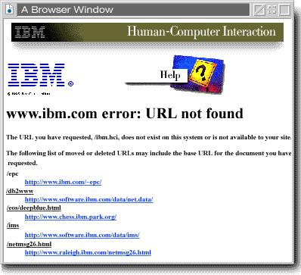

Structuring a Web site content for scanning not for read

- People rarely read Web pages word by word; instead, they scan the page, picking out individual words and sentences.
- In a recent study Morkes and Nielsen found that 79 percent of our test users always scanned any new page they came across; only 16 percent read word-by-word.

Web pages have to employ scannable text using:

- Highlighted keywords (hypertext links serve as one form of highlighting; typeface variations and color are others)
- Meaningful sub-headings (not "clever" ones)
- Bulleted lists
- One idea per paragraph (users will skip over any additional ideas if they are not caught by the first few words in the paragraph) the inverted pyramid style, starting with the conclusion.
- Half the word count (or less) than conventional writing
Organizing a content for navigation

- When confronted with a new and complex Web application users begin to build mental models, and then use these models to assess relationships among topics, and to make guesses about where to find things they haven't seen before.
- The success of your Web site as an organization of information will largely be determined by how well your actual organization system matches your user's expectations and model.
- A logical site organization allows users to make successful predictions about where to find things. If you mislead users with a structure that is not logical (or have no comprehensible structure), users will be constantly frustrated by the difficulties of find their way around. You don't want your user's mental model of your site to look like this:

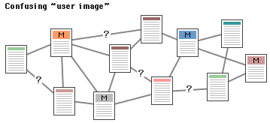

Content Organization: Hierarchical Model

- Information hierarchies are one of the best ways to organize complex bodies of information. Hierarchical organization schemes are particularly well suited to Web sites, because Web sites should always be organized as off-shoots of a single home page. Most users are familiar with hierarchical diagrams, and find the metaphor easy to understand as a navigational aid. A hierarchical organization also imposes a useful discipline on your own analytical approach to your content, as hierarchies only work well when you have thoroughly organized your material. Since hierarchical diagrams are so familiar in corporate and institutional life, users find it easy to build mental models of the site
- Any organization needs a hierarchy of importance, if only to determine basic navigation structures for the user. Most "chunks" of information can and should ranked in importance, and organized by the degree of interrelationship among units.
- Once you have determined a logical set of priorities, you can build a hierarchy from the most important or most general concepts, down to the most specific or optional topics.

- Hierarchical organizations are virtually a necessity on the Web, because most home page-and-link schemes depend on hierarchies, moving from the most general overview of your site (your home page), down through submenus and content pages that become increasingly more specific.

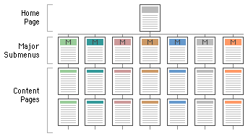
Content Organization: Hierarchical Model

- WWW sites with too shallow a link hierarchy depend on massive menu pages that over time devolve into confusing "laundry lists" of unrelated information, listed in no particular order:
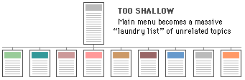

- Menu schemes can also be too deep, burying information beneath too many layers of menus:

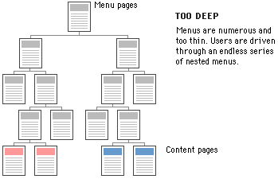

Content Organization: Sequence Model

- The simplest way to organize information is in a sequence, where you present a linear narrative. Information that naturally flows as a narrative, time line or in logical order is ideal for sequential treatment.
- Sequential ordering may be chronological, a logical series of topics progressing from the general to the specific, or even alphabetically sequenced, as in indexes, encyclopedias, and glossaries. However, simple sequential organization usually only works for smaller sites (or structured lists like indexes), as long narrative sequences often become more complex, and thus require more structure to remain understandable.

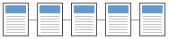

Content Organization: Grid Model

- Many procedural manuals, lists of university courses, or medical case descriptions are best organized as a grid.
- Grids are a good way to correlate variables, such as a time line versus historical information in a number of standard categories such as "events," "technology," "culture," etc.
- To be successful, the individual units in a grid must share a highly uniform structure of topics and subtopics.
- Unfortunately, grids can be difficult to understand unless the user recognizes the interrelationships between categories of information, and so are probably best for experienced audiences who already have a basic understanding of the topic and its organization.

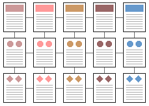

Content Organization: Complex Web Model

- This organizational pattern develops in Web sites with very dense links both to other information within the site, and information on other World Wide Web sites. It is to fully exploit the Web's power of linkage and association, but web-like organization structures can just as easily propagate confusion and fuzzy thinking about the interrelationships of your information chunks.
- Ironically, organizational webs are often the most impractical structure for Web sites, because they are so hard for the user to understand and predict. Webs work best for small sites dominated by lists of links, aimed at highly educated or experienced users looking for further education or enrichment, not for a basic understanding of our topic.
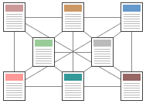
Content Organization
- A Web application content is organized using a mixture of all these structure Most complex Web sites share aspects of all these types of information structure. Except in sites that rigorously enforce a sequence of pages, your users use any Web site in a free-form "web-like" manner, just as most non-fiction or reference books are used.

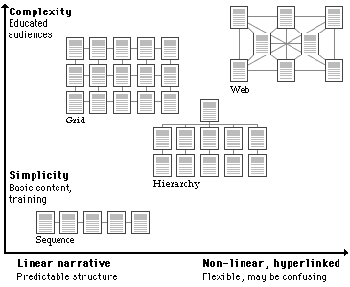

Graphic information visualization techniques are very useful for displaying views for Web sites content (e.g. Sites Maps, online shopping centre).
http://www.inxight.com/Demos/SLS_Demos/Site_Lens_Studio_Demos.html
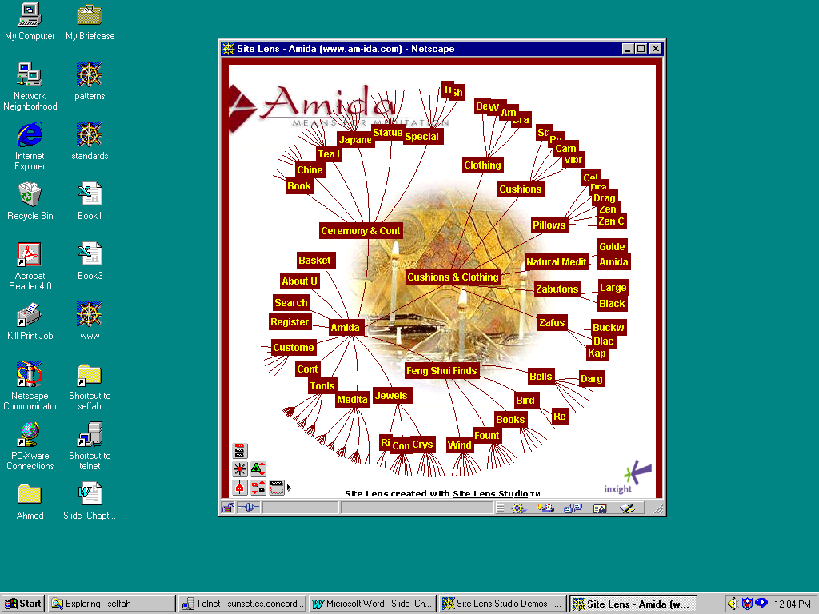
Approach for Organizing Web Applications Content: The IMI Approach
Information Mapping Inc. Method (IMI) http://www.infomap.com/method/index.htm

- Information Mapping Inc (IMI). method is an approach to analyzing, organizing, and presenting information so that it is easy for people to access, use, and remember
- IMI is both subject matter and media independent. It can be applied to the subject matter of any industry, and it can be presented on paper, on a computer screen, verbally, or in a multimedia presentation

IMI is based on seven principles and classifies all information onto seven map types.

Principles | Map Types
- Accessible details  - Chunking  - Consistency  - Hierarchy  - Integrated graphics  - Labeling  - Relevance | - Classification Map  - Concept Map  - Fact Map  - Principle Map  - Procedure Map  - Process Map  - Structure Map

IMI Seven Principles

- Accessible details: Information should be written at a level of detail that meets the users needs, and that makes the information really accessible when the user needs it.

- Chunking: Information should be grouped into small manageable units.

- Consistency: Wording should be used consistently for similar subject matters, labels, formatting. Etc.

- Hierarchy: Small and relevant units of information should be organized into a hierarchy and labeled

- Integrated graphics: Diagrams, tables, pictures, models, etc., should be used as an integral part of the text

- Labeling: A label should be used for each chunk of information

- Relevance: All the information in one chunk should relate to one main point based on that information’s purpose and function for the user
IMI Seven Map Types

- Classification Map: Sorting of a set of elements into classes or categories by the use of one or more sorting factors
- Concept Map: An idea or group of ideas that share a unique combination of critical attributes not shared by other groups and that can be referred to by a definition (e.g. a symbol or group of words). Concept maps are usually definitions with examples and possibly non-examples.
- Fact Map: A (hopefully truthful) statement presented without supporting evidence. Examples might include measurements, dates associated with events, etc.
- Principle Map: A statement of what should be done (e.g., policy), or a statement of a principle (e.g. the law of gravity)
- Procedure Map: Steps that a person performs to obtain a specific, respectable outcomes (along with the decisions that need to be made)
- Process Map: What happens over successive stages of times for some specific purpose
- Structure Map: Information which can be divided into parts that has physical identifiable boundaries

Before: A conventional version of a Web page

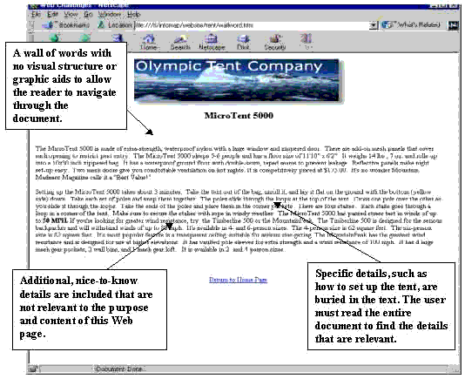
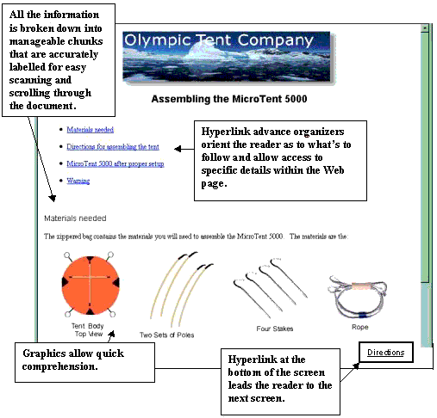
After: The Information Mapping version of a web page.
Low-fidelity prototyping

- Non-interactive representations of your Web pages. They are used to design the presentation of a Web application content. Seeing what your pages will look like helps you as a designer to refine your design and serves as a good communication vehicle between all members of the design team and to end users to get feedback.
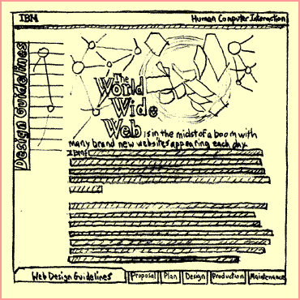
Tools and Metrics for Usability Testing

NIST Web Metrics project is to develop tools and techniques to facilitate evaluation of the usability of web sites (http://zing.ncsl.nist.gov/webmet/index.html)

- WebSAT uses a subset of usability guidelines and checks the html of a web page to determine "how well" the guidelines have been followed. The guidelines we check are grouped into the six categories: Accessibility, Form Use, Performance, Maintainability, Navigation, Readability
- WebCAT allows a web designer/usability engineer to test a proposed or existing categorization scheme of a web site to determine how well the categories and items are understood by users.
- WebVIP is a tool that can be used to conduct traditional user testing on a given set of tasks but in a rapid, remote and automated fashion.
- VISVIP is a tool, which allows a usability engineer to visualize the userpath data that is generated by WebVIP. VISVIP uses 3D graphics to produce this visualization.

A list of Web Usability Testing Tools is available at (http://usableweb.com/items/tools.html)
Tools and Metrics for Usability Testing

- Doctor HTML (http://www2.imagiware.com/RxHTML/index_noframes.html) is an online Web sites analysis program. In the text window, you enter the URL of the Web site you wish to examine. Then select the tests you wish the Doctor to perform.
- 11 tests are possible:

- Setting the report format
- Check the document for spelling errors
- Perform an analysis of the images
- Test the document structure
- Look at image syntax (e.g. overlooked image command tags)
- Examine table structure (e.g. unclosed <TR>, <TH> and <TD> tags inside a properly defined table)
- Verify that all hyperlinks are valid
- Examine form structure
- Show command hierarchies
- Show the page being tested
- Providing authorization information
A user-centered approach for Web Applications Design
IBM Approach (http://www.ibm.com/ibm/hci/guidelines/web/web_design.html)

- Proposal

- Definition: some aspects of building a high-quality web sites (e.g. defining its purpose and audience, establishing its goals) can't be automated and are crucial to a successful web sites.
- Analysis: Market analysis is a way to learn about the needs and desires of the audience you are trying to reach, check out your competition.
- Assessment: Know your limits. It's important to recognize the limitations that apply to your project, so that you can make a realistic plan. Know your site's ongoing requirements (infrastructure). Know what equipment and software your users will use to view your site.

2- Plan

- Determine site content. Site content tends to fall into three categories:
- Initial - what must be there when the site is published
- Core (static) - what information will remain there through refreshes and redesign
- Transient (dynamic) - temporary pages

- Establish user evaluation plan. Find ways to let users validate your design and content (they should be a representative sample of your target audience). Some examples of user evaluation opportunities are:

- Early - get in on a discussion group of people who match your target audience. Post a preliminary table of contents and ask for comments, suggestions and areas of interest not covered.
- Middle - circulate sample pages as they are completed and give a brief questionnaire.
- Late - give your readers the opportunity to comment on the site after its released.
3- Design

- Model/view separation
- Navigation structure
- Structuring the information space) content pages). Web users often report being "lost in hyper space". If users can't visualize the organization of content pages, they will not be able to navigate easily. A good solution is to follow IMI Method principles.
- Making the navigation scheme visible (navigation pages and techniques). An elementary formula would be to represent all navigation elements the same way. For example, using a blue button with a label indicating the destination of the link.
- Continuity and consistency: a web site is a constellation of related documents that have to be held together visually. The layout formula that is chosen must be flexible enough so it can be applied consistently to the many situations that occur in the presentation. The formula must applicable to a strong home page as well as to quieter, information rich, content pages. The visual continuity that results will contribute to the sites' visual identity and convey that site as a unique place on the net.
4- Production

- Define the site file structure
- To ensure consistency throughout your site, generate page templates for your development environment.

- Maintenance

- Advertise your web sites:
- Place keywords in the meta-information. Search engines can use this to identify the topics of your page even when those specific words don't appear in the text.
- Announce your site on relevant news groups
- Advertise on major web sites like Yahoo and Netscape
- Advertise via other media like magazines, radio, and television
- Tracking usage can helps you determine if you are reaching people as you intended and improving the web site usability (shortcuts, visited pages, etc.)
- A method for version control becomes very important when you are maintaining intranet and internet sites.

