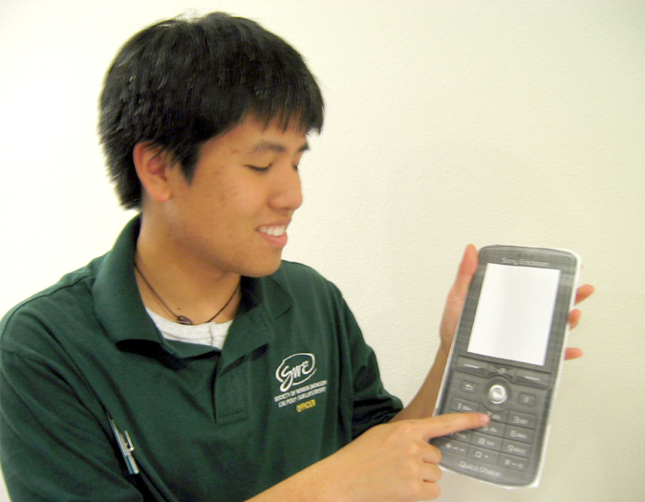 | 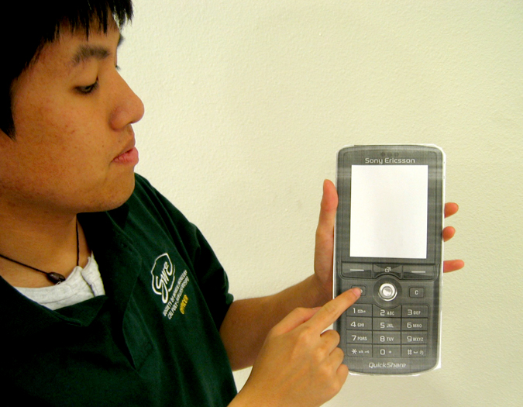
To call to someone, type the phone number or corresponding letter. The number will begin to appear on the phone screen. | If you make a mistake, press the “Back” button to begin erasing numbers one at a time.

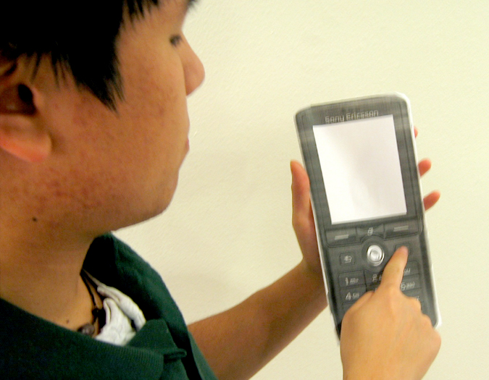 | 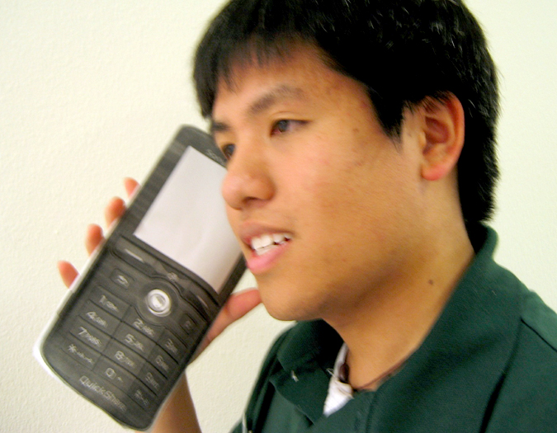
Once you have entered all the numbers,  press the “Call” button | Place the phone hear your ear. You should hear a ring. Began talking once you hear an answer.

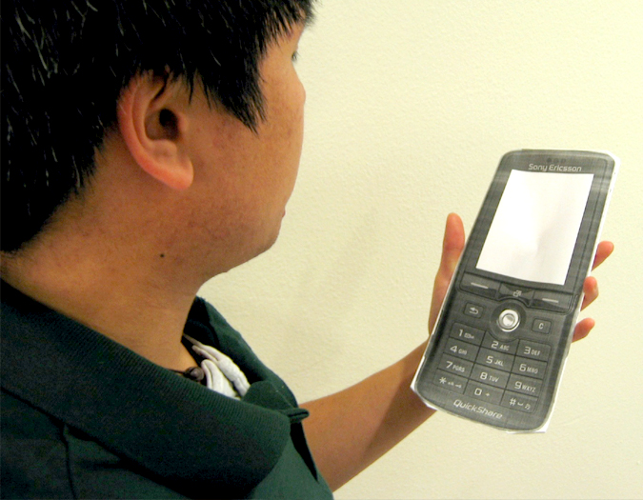 | 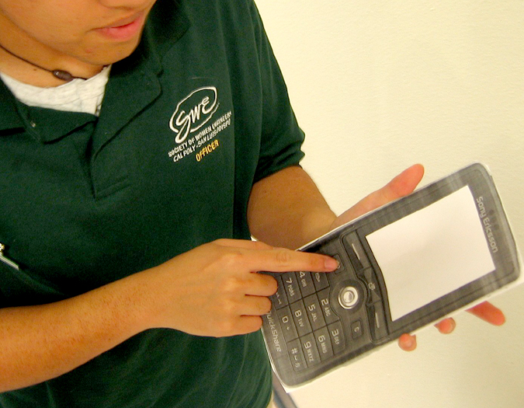
If you do not hear a ring or an answer, look at your cell phone screen and make sure the call is active. | When you are finished with your call, press the “Back” button to end your call. Then repeat the process to call someone else.

