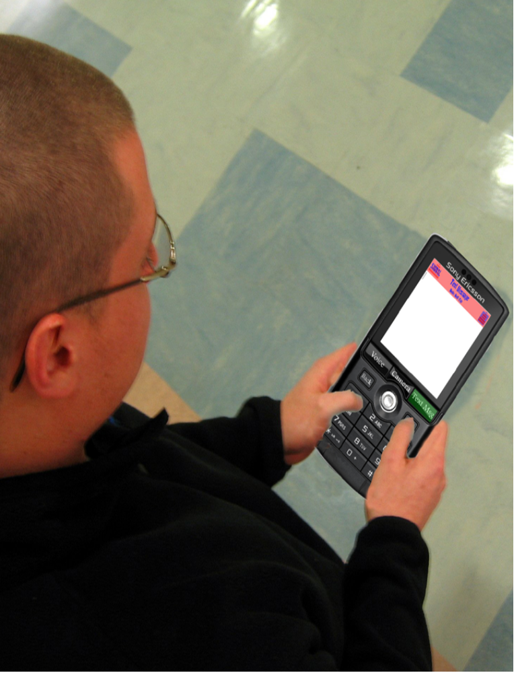 | 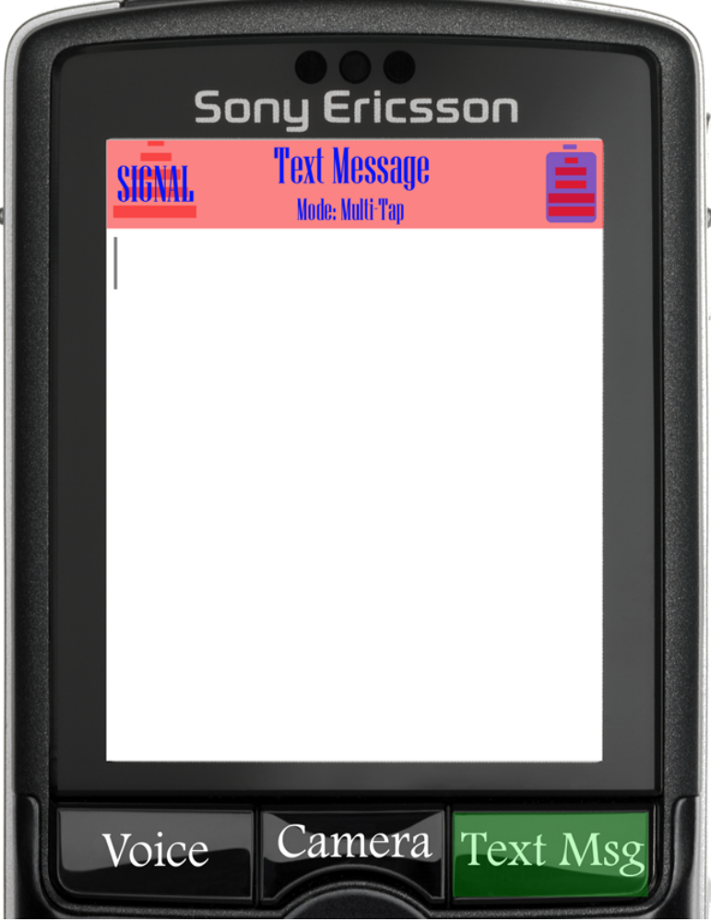
To start a text messaging session, push the “Text Msg” button. The text message window will come up. | The power user has the option to use four different text messaging modes: Multi-tap, prediction, numerical, and chorded. The user can toggle between different modes by hitting the “Text Msg” button.
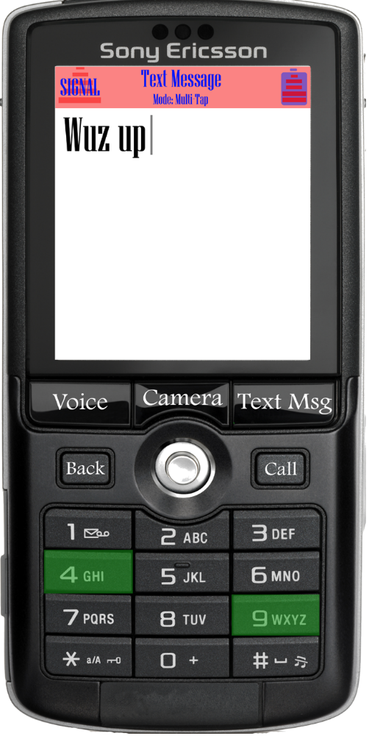 | 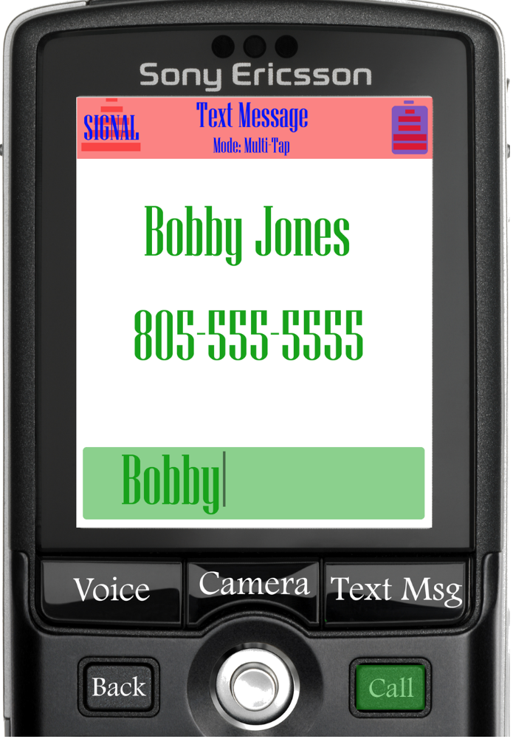
The ultimate power user can use the chorded mode to type text messages faster than ever. This allows you to use combinations of keys to type characters. This provides the freedom of multi-tap with the speed of prediction. | To send your message, push the “Call” button. Type the name of the person you want to call. The person's number will be looked up in your address book. Push the “Call” button again to send the message.

