Table of Contents

1 Introduction to ProtoJ 1
1.1 Current Focus of the ProtoJ Project. 2
1.2 Outline of this Stage of the Project. 3
1.3 Outline of Report 4
2 Contributions to the ProtoJ Project 4
2.1 Quality Assurance Testing. 5
2.1.1 Quality Assurance testing outline. 5
2.1.2 Subsumed testing for scripting. 6
2.2 User Interface Refinements. 6
2.3 Object Selection and Movement. 7
2.3.1 Mechanics of Object Selection. 7
2.3.2 Visual Representation of Object Selection. 8
2.4 Minor Contributions. 8
2.4.1 Integrating PageSetup and Layer operations. 8
2.4.2 Edit and Run Modes. 8
3 Architectural Aspects of ComponentObjects. 9
3.1 Stripping Solution 10
3.2 Layered Pane Solution. 10
3.2.1 JLayeredPane Implementation. 10
3.2.2 Normalization of ComponentObjects. 12
3.2.3 Selected Borders. 12
3.2.4 Reorganization of Containers. 12
4 Technical Details of the Quality Assurance Structure. 14
5 Conclusion 17

1 Introduction to ProtoJ
At California Polytechnic State University, students in undergraduate software engineering courses could greatly benefit from a graphical user interface (GUI) based tool that allows them to rapidly develop user interfaces without the complication of expensive professional development tools. These development tools can be hard to learn, as they are oriented towards professional engineers. Furthermore, it is also often the case with tools such as these that the focus is much more towards code generation systems that produce an end product, such as Net Beans. Code generation tools are a lofty goal, but they still tend to produce verbose and bulky code, which is not the goal of a software engineering course. Other tools, such as Visual Basic typically require a substantial amount of work that must be invested on code that will be thrown away, which is also not particularly attractive from a software engineering standpoint. Finally, current tools like the ones mentioned tend to limit the designs that can be made, as well as the creativity of the designer, with their own intrinsic limitations and heuristics.
The solution that has been crafted to alleviate this problem is called ProtoJ. It combines the features of a drawing editor with the ability to place Java Swing components quickly and easily on a mock screen. The drawing objects and component objects can quickly and easily have limited functionality associated with them in order to be able to easily build a prototype of a user interface that may be evaluated by a customer, in this case, an instructor teaching CSC205 or CSC206.
Other Cal Poly students have already completed thorough documentation on the purpose, scope, and underlying principles of ProtoJ. This information as well as documentation concerning previous work on this project can be found at http://waldorf.csc.calpoly.edu/~gfisher/work/protoj/documentation and http://waldorf.csc.calpoly.edu/~gfisher/work/protoj/requirements.
Furthermore, research pertaining to how ProtoJ compares with other similar tools available on the commercial market or from open source projects can be found in Nolan Marcie’s project report at: http://waldrof.csc.calpoly.edu/~gifisher/work/protoj/documentation.
A brief overview of ProtoJ is given here. For more detailed information use the information given above. ProtoJ consists of a main menubar, two component toolbars, and the drawing window. The first toolbar allows the user to select what type of JComponents they wish to draw on the canvas by left clicking the mouse and then dragging the bounding rectangle to the size they wish the component to be. The second toolbar operates similarly, except that the user can choose from common drawing editor shapes, such as rectangles and ellipses that can be placed on the screen. The menubar provides the usual file and edit commands such as ‘Save’ and ‘Copy’. The remaining menubar items provide functionality for universal drawing editor commands like aligning objects on the screen, as well as operations that allow ProtoJ to manipulate Swing Components. Fig. 1 shows how ProtoJ looks to a user with all the available windows open. Also, there are two simple objects on the screen that illustrate the difference in appearance of a ComponentObject, labeled ‘Button 0,’ and a DrawingComponent which is the square on the screen.
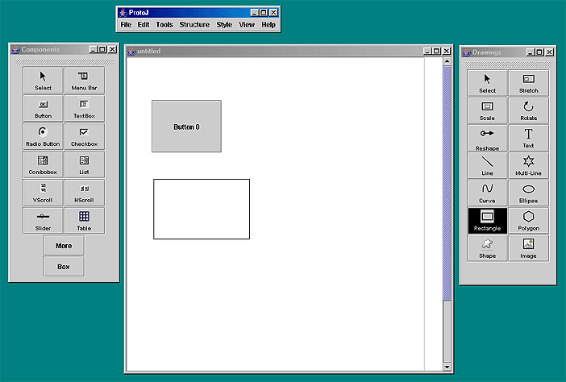
Fig 1. ProtoJ user interface

1.1 Current Focus of the ProtoJ Project.
ProtoJ is a work in progress. There have been many refinements, revisions, and additions to the original vision of what ProtoJ should be. Students working on senior projects at Cal Poly have supplied much of the work that has been done on ProtoJ. Previous senior projects have made a significant amount of progress towards the goal of combining a drawing editor and an interface that allows Java AWT components to be manipulated in an easy-to-use tool. Charles Krebs and Dianne Donahue built JDraw, a drawing editor constructed in the spirit of I-draw. Khiem Lieu and Yin Yaun spent a significant amount of time adding the Java Swing component functionality to the project and integrating the JDraw code to provide for drawing capability in ProtoJ.

Although a great deal of progress had been made on the ProtoJ project, much of it has been spread over time, involving many different Cal Poly senior projects. The actual state of the project versus the goals that were to be achieved was not in a quantifiable state. Additionally, with such a disparate time scale for when the work was done, with work being done by different teams of programmers that never communicated with each other, there existed certain inconsistencies and holes in the functionality of the tool that manifested themselves in no uncertain terms from the user perspective.

In fact, some of the challenges that ProtoJ presents are caused by the nature of it being developed in an academic environment, particularly in the quarter system. Many people have worked hard on it for an academic term, but then they have to leave. There simply is not enough time in a quarter to go through the development of a piece of software of this complexity level in its entirety. Projects may be well designed and have a substantial amount of effort put into their implementation, but particularly difficult areas or areas that contain unforeseen problems in integration tend to get passed over.
From an academic standpoint, this is an interesting phase of the project in that it encompasses many phases of the software engineering process that cannot be frequently simulated in an academic environment. Maintenance, integration, design, debugging, and testing of a partially completed project never seen before is a real world problem. The project is in a state were all the little pieces that people have assembled, or nearly assembled, have to be reconciled into one cohesive piece of software. This, assuredly, is the most difficult part of any software project.

The JDraw project is very nearly a 100% complete piece of software. The ProtoJ project has had a significant amount of work done on it, but there are areas of required functionality that have been addressed very little. The most important area lacking a large degree of functionality is in managing the JComponents on the screen. There also exists a need to refine the scripting language interface that the JComponents rely on to exhibit their limited functionality.

One of the most important parts of the project was to perform a detailed analysis of what functionality was implemented with respect to the requirements and specification change orders (SCO’s). Additionally, since so many different people in a disparate time span had worked on ProtoJ, some features of the tool had bugs that could be difficult to keep track of without some history of systematic documentation.

1.2 Outline of this Stage of the Project.
This stage of the ProtoJ project was done in two major sub-phases. The first goal of this stage was to determine exactly what state ProtoJ is in. There was a definite need for a thorough analysis of the projects state with respect to the functional requirements, usability from the user perspective, and aesthetic concerns. This analysis was achieved with an extensive quality assurance (QA) testing plan done from a user perspective.
The second phase of the project consisted of resolving anomalies that arose out of the integration of JDraw and ProtoJ. After reviewing the results of the testing, it was determined that the most important aspect of the integration that remained was making the behavior of ComponentObjects mimick the behavior of DrawingComponents from JDraw. This will be discussed in further detail in section 2.3.
After resolving some of the lingering integration problems, the remaining time allocated to the project was spent focusing on areas of functionality that had not yet been implemented.

1.3 Outline of Report
Section 2 discusses the contributions made to the ProtoJ project on an effectual level of the tool. That is, the contributions described are elements of ProtoJ that can be seen from the behavior of the tool itself by an informed user. Details of the architectural concerns and implementation can be found in section 3. Details of the layout of the quality assurance testing documentation can be found in section 4.

2 Contributions to the ProtoJ Project
Due to the nature of the project being partially completed in some areas, virtually unimplemented in others, and the need for the smoothing of the integration of the elements of JDraw with those of ProtoJ, the issues addressed in ProtoJ tend to be spread across the entirety of the code base. Concentrating on specific modules of ProtoJ was simply not a feasible option, since this was exactly the type of work that had already been done. Several weeks were spent investigating the existing implementation of ProtoJ and trying to get a feel for the relationships of all the modules as a whole. The contributions section is organized according to the order in which items were addressed, rather than particular aspects of module design or engineering topics.
Approximately a week was spent on analyzing the feasibility of decoupling ProtoJ and JDraw and implementing a plug-in interface as designed by Aaron Jensen. The documentation for this project can be found at: http://waldorf.csc.calpoly.edu/~gfisher/work/protoj-plugin/design/javadoc and
http://waldorf.csc.calpoly.edu/~gfisher/work/protoj-plugin/implementation/source/java/protoj/plugins.
The goal of this design was to modularize the project in such a way as to relieve some of the complication from having JDraw, built as stand-alone software, be the code base for ProtoJ. This solution was abandoned as impractical, as the development of ProtoJ had necessarily caused a great degree of fusion between itself and JDraw.
Some fundamental terminology should be noted here as well. Any drawing object from JDraw, such as ellipses, squares, etc, is referred to by its Java class name, DrawingComponent, which represents the shape itself as rendered on the screen as well as other attributes necessary for managing drawings. Objects in ProtoJ that represent Swing components, such as buttons, combo-boxes, etc, are referred to by their Java class name, ComponentObject, which represents the actual JComponent as well as its container and other necessary information.
Another minor terminology convention being used is that when Java classes are referred to, the standard capitalization notation is used, as in class “DrawingComponent.” Java methods are also referred to in the standard notation, as in method “leftMousePressed().”

2.1 Quality Assurance Testing.
As stated previously, the testing phase of the project was spurred by a very real need to know exactly what works in ProtoJ and what doesn’t. Areas of the project were known to need extensive re-working and not tested extensively, but the framework developed here can easily be applied to testing future additions of ProtoJ. Technical details of the QA format can be found in section 4. The quality assurance test results can be found at http://waldorf.calpoly.edu/~gfisher/work/protoj/testing/implementation/qa.

2.1.1 Quality Assurance testing outline.
Rather than perform a detailed analysis of the state of ProtoJ with a large, code-based testing suite based on white or black box testing, it was decided that a full testing suite could be performed from a user level. Systematically using every operation available in the tool ensures every method in the implementation is called. With a reasonably detailed knowledge of ProtoJ’s implementation, we can be sure that the user level testing is done intelligently, using normal, boundary, and illegal values as user inputs. If the state of the tool can be in a variety of states upon the action being invoked, the tool was tested having that particular configuration as the pre-condition for that test.
Although this approach might be a bit unusual for a project in this early stage, a significant amount of the code base for ProtoJ came from JDraw, which had been tested in a more traditional unit testing sense, but not from the integration or end user perspective. Performing an extensive end user test in this manner accomplishes system testing for the elements of JDraw that have been incorporated into ProtoJ and provides a valuable status measurement of ProtoJ overall. An added benefit of this type of testing is that there is human observation of the correctness of these operations and the effects of interleaving these operations with each other. The verification of the correctness of many of the operations of ProtoJ would be difficult to assess with purely code based testing due to the fact that the correct result for an operation is frequently that an object on the screen ‘looks right’. Generally the post conditions analyzed for the movement and creation of objects required shapes or components on the screen to retain their proper shape, size and location in the window.
The user level testing was designed with classical testing principles in mind. Tests are planned in such a way that the previous test builds the initial state for following tests. Additionally, testing was designed such that each DrawingComponent and ComponentObject type participated in a particular phase of the testing individually and as mixed groups. The results of these tests, when successful, can be used to test the interleaving of operations.
Tests involving collections are primarily used to test the functionality of operations when many items are drawn on the screen. Tests of this nature follow the standard heuristic for testing collections. A collection of no items is tested, a collection of one item is tested, a collection of two items is tested, and finally a large collection is tested. Stress testing for ProtoJ generally involved 50 objects, which is not large from a collection standpoint, but this value was considered to be more than adequate for a tool that is meant to create a streamlined user interface.

2.1.2 Subsumed testing for scripting.
Considering the visual nature of ProtoJ and the flexibility it provides in combining those visual objects with additional properties, concerns arose about the sheer volume of test cases that could be produced by stringent testing methodology. By using an intelligent approach to the testing of these areas, much of the testing of the most basic functionality of the tool can be incorporated, or subsumed, into slightly more complicated tests.
The testing for all the possible scripts, such as “File.New(),” “File.Close()” etc, that can be combined with all of the basic mouse functions such as mouseLeftUp, mouseLeftDown, and mouseMiddleUp, etc, creates a prohibitive amount of possibilities to test explicitly. The scripting language has been tested independently and is assumed to be a stable component of the system. The interface that connects the scripts to objects via the script editor is the area that is of real concern. Therefore, testing the combinations of scripts possible is subsumed in the suite as thus.
Each ComponentObjects script editor is invoked with three different base test cases. A Script with no functionality followed by a Script that calls “File.New()”, finally followed by a Script that calls at least three of the static scripting functions are all assigned to the “mouseLeftUp” operation. This will demonstrate the ability of ComponentObjects to correctly have scripting actions associated with them. Due to the independence of the scripting language compared with how it is wired to ProtoJ, all that remains to show is that each mouse action for each ComponentObject type can interact with the scripting language. Therefore, after the tests described above, each ComponentObject is only tested with each available mouse action being assigned the “File.New()” scripting action rather than all of the possible Scripts that could be associated with that mouse action.
The other area of subsumed testing involves the alignment tests and the behavior of objects when they overlap on the screen. The variety of positions used as pre-conditions for alignment tests are constructed in such a way that any reasonable test that could be performed by a separate suite of overlapping tests can be conducted simultaneously with alignment tests.

2.2 User Interface Refinements.
Following the testing phase, there were some obvious behaviors of ProtoJ that were not critical to its functional status, but none the less very annoying from a user’s standpoint, and even more annoying to someone testing the tool that had to constantly look at particularly confusing user interface traits. The cosmetic and user interface refinement changes follow.
There are two toolbars in ProtoJ. One allows the user to select from a variety of standard drawing shapes such as triangles and squares, and also allows the user to select operations to perform on those shapes, such as stretch and scale. The other toolbar is for JComponents (ComponentObjects in this case). There are buttons that allow a user to create buttons, drop boxes and other common user interface items.
However, there was no indication as to what button on the toolbar the user pressed last. This was very confusing, especially when two different toolbars can be accessed at the same time. Altering a button’s color with respect to buttons that were not last pressed now shows the currently selected button. Additionally, ambiguous icons were replaced with more straightforward JPEGS, and text labels were added to every button on each toolbar. The existing rollovers proved to be distracting and not needed with text labels and were removed.

2.3 Object Selection and Movement.

Another fundamental problem that remained in ProtoJ was resolving the behavior of ComponentObjects, which are built using the classical JComponents, like buttons, combo boxes, etc, with DrawingComponents, which were imported from JDraw and are line drawings built using the Graphics2D API. The Drawing Toolbar also had a cumbersome design for moving DrawingComponents. Two separate buttons were used for move and select operations, whereas ComponentObjects have a single move/select button.

One of the original goals of ProtoJ was to avoid the common selection characteristics of other tools. The rules concerning the behavior of selecting and moving objects combined with the behavior of the appropriate toolbar for each object type that was implemented is as follows.

2.3.1 Mechanics of Object Selection.
Objects (drawing or component) can be selected in two ways on the screen. First, an object can be selected by clicking the cursor directly on that object. DrawingComponents have to be clicked within a predefined delta distance from any of the lines that fashion the rendering for that shape. ComponentObjects can be touched anywhere within the boundary of that object, as ComponentObjects inherently do not consist of any negative space. Objects can also be selected by dragging the move/select cursor on the canvas, which will create a bounding rectangle that selects any objects that are entirely contained within the bounding rectangle. If the ComponentObjects toolbar selection tool is used, only ComponentObjects that are within the bounding rectangle are selected. DrawingComponents are ignored. The converse is true if the DrawingComponents selection tool is used, in this case ComponentObjects are ignored.

Additionally, selection of an object is not to alter the active tool on the toolbar. If the active toolbar is “DrawingComponents” with active tool “Ellipse”, touching any DrawingComponent on the screen with the cursor will select that object for movement, but not change the active tool. If a DrawingComponent is moved, and the canvas is touched again it will still draw “Ellipse.” However if the object selected with a mouse click is of a different type, the active toolbar will switch. For example, if the currently active toolbar is the DrawingComponents toolbar, with active tool “Rectangle,” touching a JButton with the cursor directly will make the ComponentObjects toolbar active, with active tool “Move/Select.”

2.3.2 Visual Representation of Object Selection.
Another element to resolve concerning object selection and movement consisted of selected ComponentObjects being visually represented as ‘selected’ on the screen. To visually indicate to the user that DrawingComponents from JDraw are selected, four small filled rectangles called ‘control points’ are drawn on the corners of a bounding box containing the object and the lines that make up the bounding rectangle are also rendered on the screen. This motif was replicated for ComponentObjects by drawing filled rectangles connected by lines on the boundary of ComponentObjects to visually indicate selection to the user.
Although it may seem a simple matter to extend the selection of DrawingComponents to ComponentObjects, here are significant differences in how this is accomplished due to the nature of these objects. The ultimate goal for any tool is to have it perform smoothly and efficiently from the end user’s point of view. Ensuring that the DrawingComponents and ComponentObjects behaved identically from the end user’s perspective was a critical aspect of the success of ProtoJ. See 3.2.1 for the details of how the implementation of ComponentObjects mimics DrawingComponents with a much different ‘back-end’ approach.

2.4 Minor Contributions.
This section discusses several relatively uncomplicated but useful additions to ProtoJ.

2.4.1 Integrating PageSetup and Layer operations.
Dianne Donahue has implemented classes to manage the "Page" and "Layers" options for ProtoJ, but they had not been integrated into the tool. Although the integration wasn’t a particularly difficult task, it did involve a thorough knowledge of the hierarchy and design of ProtoJ. Interestingly, it was in this phase, where another person had completed the implementation of a single menu bar item's functionality that the difficulties that can arise from teams not working in the same time frame manifested itself. Ensuring that the proper references from farther up in the hierarchy were properly maintained and integrating the classes in such a way that they meshed with the current implementation of the project still took a full eight hour day, despite the excellent work that Dianne performed. Differences in UI and update philosophy were marked here, as well as the fact that changes the Dianne could have never foreseen required some minor re-working of her code.

2.4.2 Edit and Run Modes.
The resolution of how ComponentObjects are represented on the screen in selected or non- selected states from an implementation standpoint readily provided a mechanism to implement the desired behavior of the edit and run modes of ProtoJ. From the ‘Edit ->Mode’ option, two choices can be made. ‘Edit’ mode puts the tool in a state where objects on the canvas can be created and have their attributes, such as size, location, color, etc, manipulated. In ‘Run’ mode objects respond to user interaction by performing the scripts associated with them.

3 Architectural Aspects of ComponentObjects.

For an important distinction between DrawingComponents and ComponentObjects, see the introduction to section 2. As stated previously, one of the fundamental problems that remained in ProtoJ was resolving the behavior of ComponentObjects, with DrawingComponents, which were imported from JDraw. ComponentObjects are built using standard JComponents, like JButtons, JComboboxes, etc, and extending these classes to provide the specific functionality of ProtoJ. DrawingComponents are built by building “GraphicObjects” extended from Java.Applet and making line drawings using the Graphics2D API.
Using the Model, View, Process (MVP) paradigm and a package of predefined View and Model classes provided by Dr. Gene Fisher, the objects on a ProtoJ window are painted on a JPanel that is referred to as the CanvasPage. The painting that takes place in the overridden paintComponent method of a CanvasPage does not require additional fine-tuning to render ComponentObjects or DrawingComponents correctly on the screen.

However, the implementations of these objects in Swing, and the way they respond to AWT events, are vitally different. Therefore care had to be taken to ensure that the drastically different implementations provided by Swing did not produce anomalous behavior between ComponentObjects and DrawingComponents from the users perspective, as these two things should be the same. DrawingComponents rely on mouseListeners in the Canvas to indicate a need for their change of state. The hierarchy of JComponents and Containers dictates that the listeners for the JComponents is higher than that of the Frame, so the basic precept that the model is informed of what changes to make to its state by messages passed from the view based on events from the CanvasWindow doesn’t hold. Furthermore, based on the hierarchy, the decision making process that ProtoJ relies on based on Events registered in the CanvasWindow will never be registered if the mouse event is directly on a ComponentObject.

Moreover, JComponents must behave differently based on the mode of the tool, which can be in run mode, where the functionality assigned to the JComponent from the scripting language is the desired result from an event, and edit mode, where the JComponent's position, size, color, etc. can be manipulated if the ComponentObject is selected. Typically, JComponents have a single mousePressed response based on a mouse event, and in the case of ProtoJ, it’s required that the ComponentObject behave differently on left click mouse events depending on what mode the user currently has the tool in. Having the listener check or be notified of the tools mode on each event is undesirable from a design standpoint as it introduces unnecessary coupling.

Additionally, DrawingComponent shapes are line drawings, and it is a relatively straightforward task to decide if that line drawing had an event within some delta of its line drawing. JComponents make things more complicated, as it doesn’t matter where you hit the component with a mouse event; it just recognizes the fact that an event occurred. This fact makes it particularly difficult to have a point of reference for sizing operations such as stretch and scale. Also, manipulating the graphics2D environment of a JComponent contained in a ComponentObject is much more difficult than in the DrawingComponent area due to the way Java repaints Components based on the containment hierarchy.

3.1 Stripping Solution

The idea was brought about to remove the standard listeners from the JComponent contained inside each ComponentObject when the tool was in “Edit” mode and replace them with appropriate listeners to handle the movement, resizing, and other editing operations available in ProtoJ. Then when the tool is placed in “Run” mode the MouseListener for the JComponent would be added to each ComponentObject in order to associate the proper scripting behavior for that object. Several weeks were spent analyzing the feasibility of this solution by studying the Java API and writing small test programs. This approach was abandoned due to the fact that currently, the way JComponents are wrapped by Java, it is not possible to retrieve specific listeners, and the overhead of storing large arrays of listeners that were difficult to put back correctly was prohibitive.

3.2 Layered Pane Solution.

The best solution is based on having two ways to keep track of the state of a ComponentObject, which is very attractive in this situation, as it models the two states of “Run” and “Edit” quite naturally. The behavior of a ComponentObject is very different based on the mode in which the tool is in. The fundamental task of event handling in edit mode is for any ComponentObject to be able to recognize the fact that it is selected. A considerable amount of time was spent reviewing the requirements for the project and combined with the experience of user level testing, to precisely determine what it meant for a ComponentObject or DrawingComponent to be ‘selected’ and what behavior that state entailed for the two types of objects.

3.2.1 JLayeredPane Implementation.
A JLayeredPane is used to provide the means to efficiently model the behavior of a ComponentObject based on the mode of the tool. When a user creates a new ComponentObject, the object is built as per the specification of the extended children of the abstract ComponentObject class such as ButtonObject, RadiobuttonObject, etc. However, an InvisibleButton object is also created at instantiation that will ‘hover’ over the actual ComponentObject in “Edit” mode. Both the InvisibleButton and the ComponentObject are placed in the JLayeredPane’s drag layer, but with different index parameters specifying that the InvisibleButton is to be placed ‘on top’ of the ComponentObject. Then the objects and their container are sized and placed in the frame. The situation is shown in Fig2.
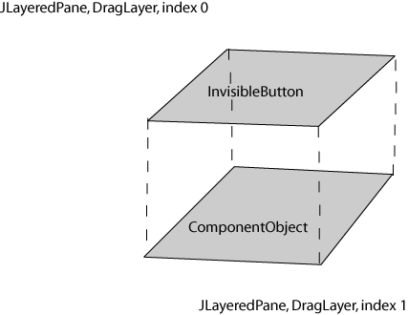
Fig2. JComponents in a JLayeredPane
When in “Edit” mode, the MoveableButtonMouseListener is responsible for notifying the parent model that that particular object has been touched with the cursor and is ‘selected’. It is still possible to select many items with the ComponentObject Toolbars “Move/Select” tool, but since the mouse event occurs on the CanvasWindow rather than on a specific ComponentObject, the canvas is responsible for testing whether multiple ComponentObjects are within the CanvasWindow's bounding rectangle. The MoveableButtonMouseListener is also responsible for effecting the movement of a single button (which can be used to generate movement of groups of objects based on the relative movement of the object that is moved by the cursor), and placing the object in its final position based on where the cursor is released.
In “Run” mode, the index positions of the InvisibleButton and the ComponentObject are reversed, and the script that is associated with the ComponentObject will be executed when the ComponentObjects mouseListener receives the corresponding mouse event, i.e., left Pressed, middleMouseUp, etc.
This structure also easily facilitates the show/hide operations in ProtoJ. A list of the ComponentObjects is maintained in ProtoJ and these can be shown or hidden, depending on their current state, by traversing the list and making the appropriate method calls to setVisible() and setEnabled().

3.2.2 Normalization of ComponentObjects.
ProtoJ utilizes a live drag system for moving objects on the canvas based on normalizing the AWT.Event with respect to the JComponent and all the Containers it may reside in upon a leftPressed() method call. Once this normalized position is established, drag events simply call setLocation() repeatedly based on the normalized position, and the ComponentObject is rendered as often as mouseDragged() is called. This style of implementation when used with double buffering provides a uniform, visually consistent movement of the object on the canvas. This is accomplished with a simple MouseMotionListener class that is imbedded in every InvisibleButton, which is a member of ComponentObject.

3.2.3 Selected Borders.
DrawingObjects have squares painted on the corners of their bounding rectangle when they are selected on the canvas. In order to mimic the behavior of selected DrawingObjects, ComponentObjects had a border added to them. In order to not obscure the painting done by Java on the actual JComponent that the ComponentObject consists of, a JPanel was added to the palette layer of the JLayeredPane that holds the InvisibleButton and the actual JComponent that we wish to have functionality for. This arrangement provides an easy way for all the painting for a ComponentObject to be done correctly while maintaining the visual hierarchy of items being ‘laid over’ each other in a natural manner.
A SelectedBorder class was implemented and added to each ComponentObject by attaching it to the JPanel in the palette layer. When the paint method is called for the root container of the ComponentObject, i.e., the JLayeredPane, the paint method checks to see if there is a border associated with the JPanel. The paintBorder() method of SelectedBorder consists of one IF-ELSE block. If the ComponentObject is not selected on the canvas, it merely exits the method body. If the ComponentObject is selected, the Graphics2D object is retrieved for the JPanel’s environment. Offsets are calculated to take into account the width of the containers and the desired stroke for the outline. Then an outline of the ComponentObject’s bounding rectangle is painted as well as four filled squares, one on each corner of the bounding rectangle, that serve to reproduce the look of control points in DrawingComponents.

3.2.4 Reorganization of Containers.
From a design standpoint, ComponentObjects were built with a few missing pieces of information. Much of the code from ProtoJ relied on large switch statements utilizing ‘instanceof’ operations to decide what to do based on the type of component, even for simple operations. Additionally, with the JLayeredPane solution, redesign of ComponentObjects and their containment hierarchy was necessary. ComponentObjects were slightly redesigned to have class members that consisted of the their outermost container, the JLayeredPane, and an InvisibleButton. Specific ComponentObjects that require another layer of containment, like radio buttons, are placed in another JPanel for grouping and have an array consisting of their ButtonGroup, ListModel, etc. The relationship between these objects is shown in Fig 3.

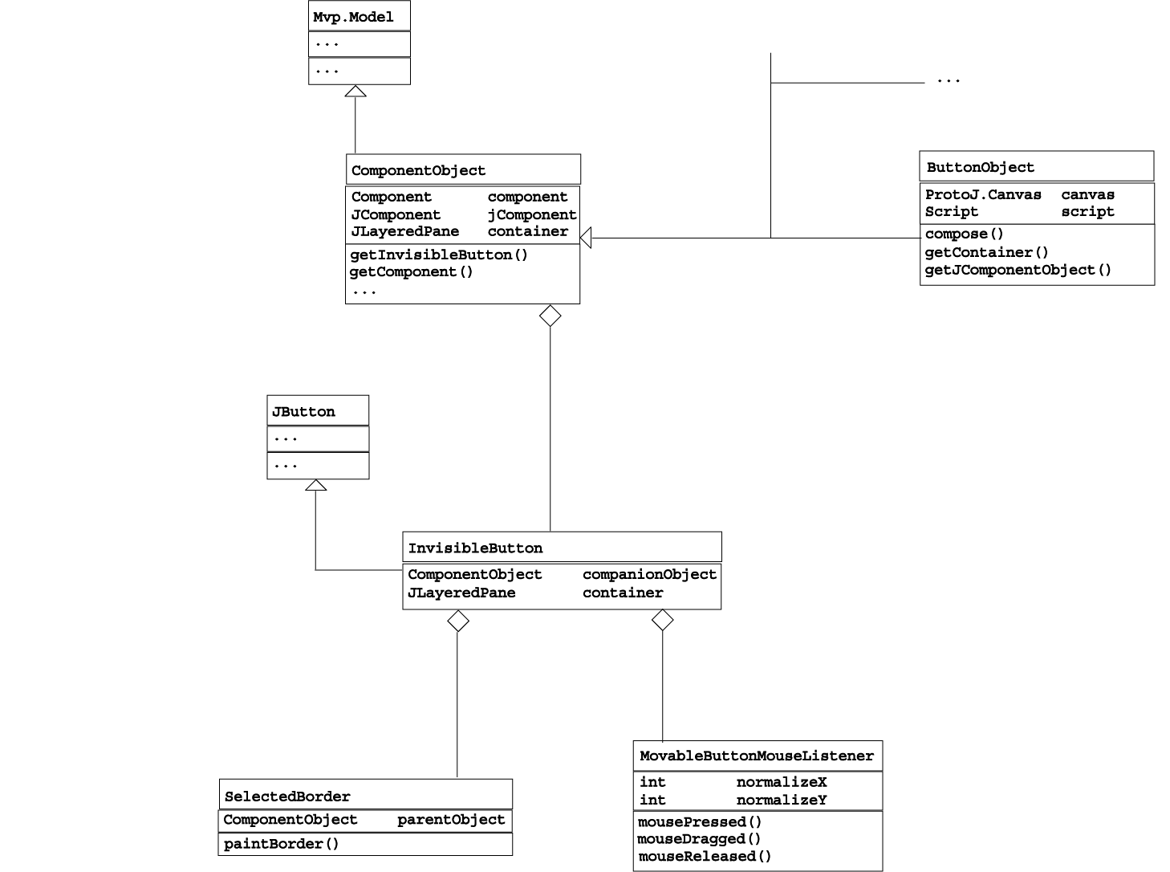

Fig 3. ComponentObject class design
Accessors were modified such that the top-level container can always be obtained by calling getContainer() without need for casting to a particular type of ComponentObject. Inheritance features in Java that ‘hide’ information can be exploited as follows. The abstract class ComponentObject has class member:

/** The container that holds the InvisibleButton and the 'real' JComponent */ protected JLayeredPane container;
and abstract method:
/*
* Return the ComponentObjects’s outermost container.
*/
public JLayeredPane getContainer(){
return container;
}
Being abstract, this class cannot be instantiated. So in each specialization of a ComponentObject, the following code, this particular code being taken from ButtonObject, is included. The constructor instantiates a new JlayeredPane to hold the objects, and the overridden getConatiner() method returns a non-null JLayeredPane that belongs to the appropriate ComponentObject without casting.
/**
* Construct the ButtonObject object
*/
public ButtonObject(protoj.protoj.Canvas canvas) {
this.canvas = canvas;
container = new JLayeredPane();
setSelected(false);
…
jcomponent = new JButton(name);
}
/**
* Return the entire ComponentObject container with it's listener button and
* 'real' component as a Component. You have to have this with the 'hiding
* that's done from the super class.
*/
public JLayeredPane getContainer() {
return container;
}
Specific ComponentObjects were also modified so as to always return the correct Jcomponent so that it can be modified by the user a required regardless of the layers of containment that that particular ComponentObject may require.

4 Technical Details of the Quality Assurance Structure.
The structure of the quality assurance (QA) documentation is based on a directory hierarchy that follows the command hierarchy of ProtoJ. The root directories of the QA documentation correspond directly to the top-level command menu for ProtoJ, i.e., there exists one directory for each top-level command option, which are the menu bar, the component toolbar, and the drawing toolbar. Each directory contains files for the testing of the functionality for those root level operations. Inside each directory there is one file for each ProtoJ command available in that menu or toolbar. The file consists of a table in Microsoft Excel format describing the specific pre and post conditions for each test case. If submenus can be accessed in a particular menu option, a directory exists that corresponds to that submenu and contains the files that describe the testing for the operations available in the submenu.

Consider a concrete example testing the “Structure” menu from an end user’s point of view. The corresponding perspective from the users standpoint when viewing the tool is shown in Fig 4.

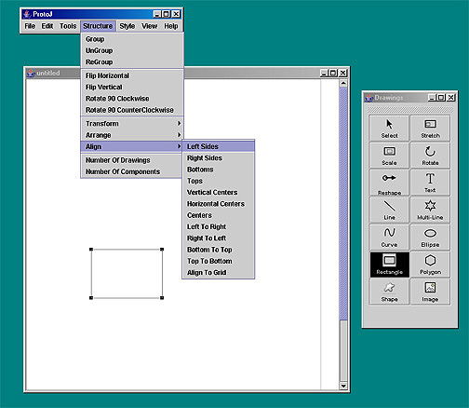

Fig 4. User’s perspective While Testing.
Particular commands that can be executed in the “Structure” menu, such as “Group,” “Flip Horizontal,” etc. will each have their test results in a .qa file in the “Menubar/Structure” directory. Entries in the “Menubar/Structure” menu that are submenus, such as “Transform,” “Arrange,” and “Align” will be represented in new directories. In this case, consider the AlignLeft_sides command, which will be contained in the “StructureAlignLeft_sides.qa” file, in the Menubar/Structure/Align directory.
The title of the file denotes what operation is being tested and is labeled by the path of commands to reach that operation. Each new capitalized word represents the position in the command hierarchy and the last word represents the actual command being tested. This is followed by the last date the tests were administered. Fig 5 shows and excerpt of the StructureAlignLeft_sides file located in the Menubar/Structure/Align directory.
StructureAlignLeftsides
7/24/03
Case  No. | Inputs | Expected Outputs | Remarks | Result
1 | Structure -> Align -> Leftsides.  0 selected Drawing  Components. | Don’t crash | Error range | Pass.
2 | Structure -> Align -> Leftsides  1 selected text item. | Do nothing. | One | Pass.
3 | Structure -> Align -> Leftsides.  Selected:  A Line  A Multiline  A Curve | Align the Drawing Components according to their leftmost X coordinate.  Don’t Distort or damage  shapes. | Some | Pass.
4 | Structure -> Align -> Leftsides.  Selected:  3 Line  3 Multiline  3 Curve  3 Ellipse  3 Rectangle  3 Polygon  3 Shape  Text: “HI DAVE” |  | A bunch | Pass.
5 | Structure -> Align -> Leftsides.  0 selected Components. | Don’t crash | Error range
Fig 5. AlignLeftSides Test Example.
Each individual test is marked with a case number for easy reference. Each test has a specific input recorded in the “Input” cell of the table. The “Input” cell consists of a reiteration of the command path followed to perform the test. The “Input” cell also contains the inputs for that test, which using the user level testing plan can be said to be the ‘state’ of ProtoJ at the time of the test. Tests that involve collections of selected items are denoted by an input of “Selected:” followed by a list of the selected items.

The “ExpectedOutputs” column lists the results that are expected from performing the operation according to the requirements or logged SCO’s. It should be noted that ProtoJ is designed primarily with a “no response” error system. The tool is designed for use by people with above average computer skills even if they are relatively new to software engineering. Due to the myriad of strange and simply unintelligent things one could ask ProtoJ to do, it was deemed impossible to handle every instance where an application exception could be raised. ProtoJ assumes that users will make intelligent decisions about the layout of items in ProtoJ with respect to Euclidean geometry, etc. Although somewhat subjective, decisions were made about what erroneous inputs cause ProtoJ to simply not respond and what reasonable, but still erroneous, inputs merited feedback from the system in the form of an error dialog. For example, test case number two in Fig. 5 asking ProtoJ to align the left sides of a single DrawingComponent does not make much sense, and in cases like this, ProtoJ simply ‘does nothing’, as noted in the “ExpectedOutputs” column. This is the standard “ExpectedOutput” entry for tests that do not require specific error dialogs.

The “Remarks” column is to log any notes about the particular type of testing that is being employed for that test case, or any other noteworthy testing concerns. For example, a certain test case may be testing an input for legal, boundary, or illegal input values and should be so marked in the “Remarks” column. The test file in Fig. 5 above for cases one through four use the classical base test cases for collections of an empty collection, a collection of one, a collection of some, and a collection of many, with ‘some’ and ‘many’ being defined appropriately in the scope of the requirements.

Both the “ExpectedOutputs” and “Remarks” columns are left blank if the entry for that test corresponds to the entry from the previous test case. Some test orderings are built such that the expected outputs and remarks are the same for many different inputs. Rather than have long columns of duplicate cell entries, tests with the same pre and/or post conditions are simply left blank. To find the appropriate information simply look up in the table until an entry is found, and this will correspond to the proper information for all the following tests with blank columns.

The “Result” column is used to record the result of the test in a pass or fail fashion. Tests that pass are simply marked “Pass”. Tests that are marked fail are marked “fail,” and a general description of in what regard the test failed is recorded, possibly with references to the particular requirement or SCO that the tool does not meet. In some cases the test is simply marked “fail.” This indicates that the functionality missing is known to not exist at all, or that that particular aspect of the tool is known to need extensive redesign.

5 Conclusion
Although ProtoJ still requires implementation work to be fully functional, a great deal of progress has been made towards combining ProtoJ and JDraw in such a way as to provide a uniform, intuitive, user friendly tool capable of producing high quality mock ups of user interfaces. Reconciling the behavior of ComponentObjects and DrawingObjects is a critical step in ensuring that this progress continues. The testing done provides an excellent framework for future system testing and is an invaluable tool for determining what the launch critical items of concern for ProtoJ are.
The project was also an excellent exercise in handling a project that has been designed by other teams of software engineers. The designers of a project have the ultimate vision and knowledge of how the project is supposed to fit together and work from a modeling standpoint. Being able to take a project designed and implemented by others and understand a large piece of software and improve upon it is a critical real world skill.
ProtoJ is in a state such that Dr. Fisher is considering simple removing access to the areas of functionality that have yet to be completed and bring the tool to Cal Poly Computer Science 205 classes, which will provide even more insight into how valuable ProtoJ can be in a development environment. This will certainly provide further means to improve the project and should spark more interest from students, prompting them to join in working to develop ProtoJ to its full potential.

