ProtoJ Prototyping Tool - Generate

by
Nam H. Nguyen

Computer Science Department
College of Engineering
California Polytechnic State University
June 11, 2004
Dr. Gene Fisher

TABLE OF CONTENTS

PAGE
ABSTRACT iii
LIST OF FIGURES iv

Section

1 Introduction 1

1.1 Description of the Problem 1

1.2 Overview of the Solution 1-2

1.3 Limitations 2

1.4 Outline of Report 2

2 Scenario of System Use 3 – 8

3 Design and Implementation 8 – 13

4 Related Work 13

5 Conclusion and Future Work 14

Abstract
The goal of this senior project was to design and implement a prototyping tool to rapidly develop user interfaces without the complications of a commercially used tool. At California Polytechnic State University, it can be frustrating trying to learn new complicated tools while taking a software engineering class. This prototyping tool eases this complication with its development targeted for this class. The implementation was done in Java (JDK 1.4.2).

LIST OF FIGURES

Figure 1: The initial state of the ProtoJ application
Figure 2: ProtoJ application with components on canvas
Figure 3: Java version of interface with components
Figure 4: UML diagram of showing where the Generate
class fits in the overall implementation
3
4
8
12

1. Introduction
This document defines requirements for the ProtoJ Prototyping Tool’s Generate option. Generate is located in the File pull-down menu and generates java code for a selected canvas containing images and components. Other students have already written thorough requirements and specifications for the ProtoJ Prototyping Tool and can be viewed from the following link:
http://waldorf.csc.calpoly.edu/~gfisher/work/protoj/requirements

1.1 Description of the Problem
This Generate option has never been implemented and is needed for the ProtoJ tool. With it, users can simply draw on a canvas and then convert the drawing to Java code. When the Java version is compiled and run, it will be efficiently executing the Java program instead of an interpreted prototype. This will help users to simply draw out what they want their GUI design to look like instead of having to spend time figuring out how to implement them.

1.2 Overview of the Solution
The implementation of Generate is basically to create its own class located in the File package. The necessary instance variables will be extracted to be used such as the component names, file names used as the class name, coordinates where the components are placed, etc. These names and values will be used to create the Java source code according to the template that will be explained later.

1.3 Limitations
The implementation of the canvas generated to Java source code will not use the common layout such as a grid layout or border layout; a null layout will be used instead. With this layout, the coordinates are explicitly specified. If the user wishes to use another form of a layout design, they must go into the generated code and manually modify it themselves.

1.4 Outline of Report
The remaining of the report are explanations and examples of how ProtoJ’s implementation of File→Generate will work. Some screen shots are added as well as an overview of the commands related to this function. There are also comparisons of this functionality to other related works and the status of the implementation.

2. Scenario of System Use
The following is a screen shot of the ProtoJ interface when it is first launched:
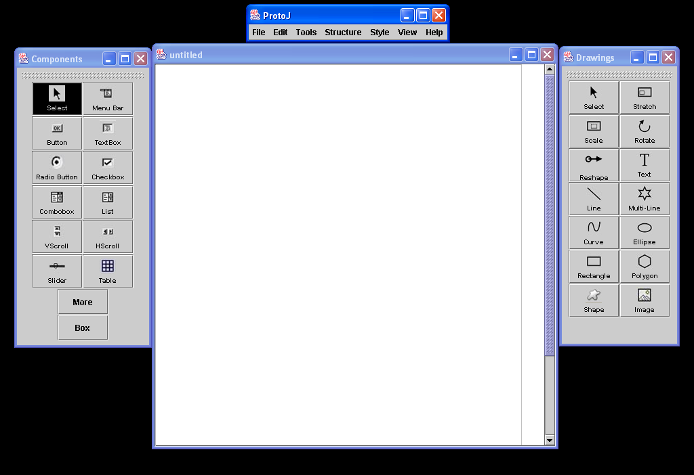
Figure 1
The interface consists of the main menu bar, a component menu, a drawing menu, and the canvas.

A screen shot of each of the components that are drawn on the canvas are shown here:
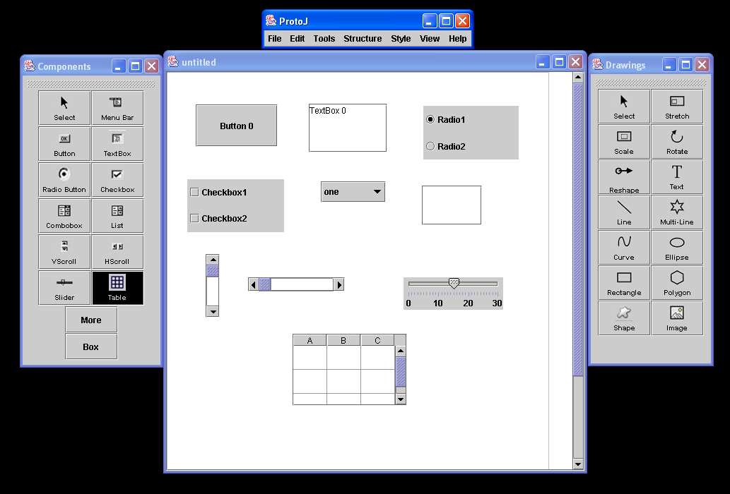
Figure 2
After the File→Generate command is invoked, the following code is generated and stored in the generate folder where the canvas was saved.
import java.util.*;
import java.io.*;
import java.awt.*;
import java.awt.event.*;
import javax.swing.*;

/****
* Class xinherited from JFrame. This code
* is generated from the ProtoJ Prototyping Tool canvas.
* Code to generate this class is written by Nam H. Nguyen.
*
* @author
*/

public class example extends JFrame
{
/**
* Instance variable declaration
*/
JButton Button0 = new JButton("Button 0");
JTextArea TextBox0 = new JTextArea("TextBox 0");
JRadioButton RadioGroup0 = new JRadioButton("Radio Group 0");
JCheckBox CheckBoxGroup0 = new JCheckBox("CheckBox Group 0");

String[] comboBoxValue0 = {"one", "two", "three", "four", "five"};
JComboBox ComboBox0 = new JComboBox(comboBoxValue0);

String[] listValue0 = {"one", "two", "three", "four", "five"};
JList List0 = new JList(listValue0);
JScrollBar Vertical0 = new JScrollBar(JScrollBar.VERTICAL);
JScrollBar Horizontal0 = new JScrollBar(JScrollBar.HORIZONTAL);
JSlider Slider0 = new JSlider(0, 30);

String[] tableValue0 = {"A", "B", "C"};
Object[][] tableData0 = {{"", "", ""}, {"", "", ""}, {"", "", ""}};
JTable Table0 = new JTable(tableData0, tableValue0);

/**
* Constructor
*/
public example()
{
super("example");
compose();
pack();
setVisible(true);
}

/**
* Method compose puts the components on the canvas at
* specific locations using a null layout and set the
* component attributes.
*/
protected void compose()
{
JPanel panel = new JPanel();

panel.setLayout(null);
panel.setPreferredSize(new Dimension(600, 600));

// set attributes for button component
panel.add(Button0);
Button0.setBounds(41, 46, 116, 60);

// set attributes for textbox component
panel.add(TextBox0);
TextBox0.setBounds(201, 45, 111, 69);

// set attributes for radio button
panel.add(RadioGroup0);
RadioGroup0.setBounds(363, 48, 135, 76);

// set attributes for check box
panel.add(CheckBoxGroup0);
CheckBoxGroup0.setBounds(29, 152, 137, 75);

// set attributes for combo box
panel.add(ComboBox0);
ComboBox0.setBounds(218, 155, 92, 30);

// set attributes for list
JScrollPane listScrollPane0 = new JScrollPane(List0);
panel.add(listScrollPane0);
listScrollPane0.setBounds(361, 161, 85, 56);

// set attributes for vertical scrollbar
panel.add(Vertical0);
Vertical0.setBounds(55, 258, 20, 90);

// set attributes for horizontal scrollbar
panel.add(Horizontal0);
Horizontal0.setBounds(115, 291, 137, 20);

// set attributes for slider
panel.add(Slider0);
Slider0.setMajorTickSpacing(10);
Slider0.setMinorTickSpacing(1);
Slider0.setPaintTicks(true);
Slider0.setPaintLabels(true);
Slider0.setBounds(335, 291, 141, 46);

// set attributes for table
Table0.setRowHeight((int)(102/3));
JScrollPane tableScrollPane0 = new JScrollPane(Table0);
panel.add(tableScrollPane0);
tableScrollPane0.setBounds(178, 371, 162, 102);

getContentPane().add(panel);
}
}

When the above code is compiled and run, the interface will look like the following:
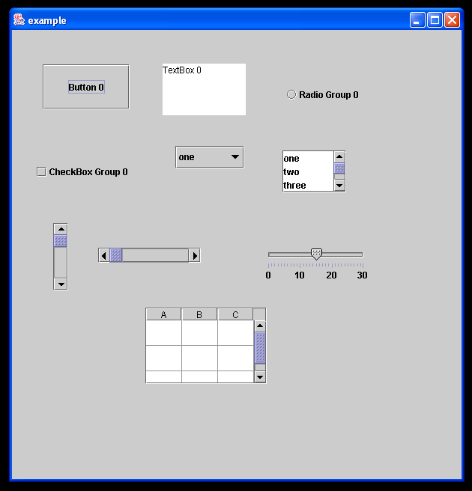
Figure 3

3. Design and Implementation
This is a template of what the Generate source code will look like:
import "javax.swing.*";
import "java.util.*";
import "java.awt.*";
import "java.awt.event.*";

/****
*
* Suppose we have a canvas with a Button at 100,200, another
* button at 100, 300, and a text box at 100 400. Suppose also that
* the names of these components are "Button 0", "Button 1", and
* "TextBox 0".
*
* This file is the java code that's generated by File->Generate.
* Variables to be filled in are in angle brackets. Here's what they
* refer to:
*
* <canvas name> root name of canvas, from window title bar
* <component name> string name of each component
* <bounds> bounds of ComponentObject, hopefully from
* getBounds
*
* The conventions for the layout of this class are the following: <ol>
*
* <li>extends JFrame</li>
* <li>has a null layout, so components are positioned
* absolultely</li>
* </ol>
*/
public class <canvas name> JFrame
{
/** Button at 100,200 */
JButton Button_0 = new JButton("<component name>");

/** Button at 100,300 */
JButton Button_1 ... ;

/** TextBox at 100,400 */
JTextField_0 ...;

/** Constructor */
public <canvas name>
{
compose();
pack();
setVisible();
}

protected void compose()
{
...

Button_0.setBounds(<bounds>);
}
}

All images drawn on the canvas are saved in a Generate folder in the directory from which the ProtoJ application was invoked. The class name is the same as the canvas name and the class will inherit JFrame. A Generate class that is the implementation of the File→Generate function is created in the File package. The following classes are imported when java code is generated from the canvas:
import javax.swing.*;
import java.util.*;
import java.awt.*;
import java.awt.event.*;

Comments are generated for the class description, instance variable declaration, constructor, compose method, and for each time the instance variable attributes are set.
These are the minimum requirements, but if more are needed, the user must manually edit the code themselves. The naming conventions of the components themselves are the same as the names of the components when drawn on the canvas. Because the specific locations of each of the components are known, a null layout is used to place them at the correct absolute position. Again, if the user wishes to use a border layout, a grid layout, etc, they must manually edit the code themselves.
The UML diagram showing where the Generate class fits in the overall implementation is shown here:
components
components_ui
drawing
drawing_ui
protoj

File
protoj
dir
aSavedCanvas
allSavedCanvas
canvasIndex
file
fileClose()
fileCloseAll()
fileExit()
fileGenerate()
fileImport()
fileNew()
fileOpen()
filePrint()
fileRevert()
fileSave()
fileSaveAll()
fileSaveAs()
getCurrentDir()
getFileName()
getProtoJ()
redrawActiveCanvasWindow()
file
file_ui
protoj
protoj_ui
FileFilter
accept()
getDescription()
Generate
protoj
file
comboBoxNum
listNum
tableNum
generate()
getFileInput()
getRootFileName()
Model
View
Figure 4
The implementation of the Generate class consists of a constructor that accepts a reference to the top model ProtoJ object and the File object. It has a generate() method that is the majority of the code, a getFileInput() method that lets the user save and returns the name of the file, and finally a getRootNameMethod() which returns the root file name.
The instance variables used are comboBoxNum, listNum, and tableNum, which are the count of how many of these components are drawn.

4. Related Work
Other related works compared to the ProtoJ Prototyping Tool are Visual Basic and NetBeans. Visual Basic typically requires a lot of time and effort with figuring out the code that is generated. NetBeans is a far too complicated tool to be used for a software engineering class. Unless the user is familiar with the IDE, it will probably take a while to just to explore the interface. Current tools like the ones mentioned tend to limit the designs that can be made, limiting the creativity of individuals. ProtoJ combines the features of a drawing editor with the ability to place Java Swing components quickly and easily on a screen. The drawing objects and component objects can quickly and easily build a simple prototype to show to customers.
5. Conclusions and Future Work
The File→Generate function of the ProtoJ Prototyping Tool is fully implemented, except for the menu bar component that was not finished. We wish to have the functionality of handling boxes and an option to provide the user with which location they wish to place the output folder. This part of the project only works to generate code for the component objects. Future plans should also include generation of Java code for the drawing components on the canvas.

