Testing the ProtoJ Prototyping Tool

Paul Avedissian

Computer Science Department

California Polytechnic State University

December 2005

Abstact

Background
The ProtoJ project needed a formal testing framework to facilitate proper unit testing. JUnit was selected because it integrated nicely into the project, and is able to run independently, or integrated into an IDE. A test harness was created to mirror the class and package hierarchy, and integrated into the Concurrent Versioning System (CVS). Test stubs were created for each method, as well as a package-level Test Suite. Our intention was to start unit testing in the hope of performing integration testing the packages, and eventually the entire project. Our focus was on the Graphical Analysis Testing

Results
The result of our unit testing revealed several problems in the drawing functionality in terms of zooming, and how the application handled the resizing of drawings. Solutions were found and eventually fixed. Complete unit testing was unable to be completed entirely and subsequently, integration testing was not accomplished.
1. Introduction

The ProtoJ project has been worked on by several students over a span of several years. The focus during its development cycle has been primarily development, not QA Testing. As a result, User-Level testing was performed, but no System-Level testing. No testing framework was created beyond a QA matrix listing all methods and the results of any user-level testing, but the information within this matrix was outdated, and inaccurate. This project needed a focused approach to building a Functional Testing Framework

1.1 Description of the Problem

Since ProtoJ has been continually worked on by several students over a course of several years, the work performed by these students was not always concurrent, nor necessarily collaborative. User-Level testing, if performed, was only performed on the specific code that a particular student is working on. As a result, ProtoJ as a whole has never had any System-Level testing. At some point, a QA matrix was created to consolidate the known errors. The matrix listed every method within ProtoJ, the Inputs, Expected Results, and Actual Results. Unfortunately the matrix was not updated. Some methods and program functionality were not implemented because of the disjoint work performed on ProtoJ.

1.2 Overview of the Solution

Since ProtoJ was implemented in Java, it was possible to use JUnit as a way of building a system-level testing framework. The NetBeans IDE was used because it directly implemented the JUnit framework into the IDE, and allows a simple way of automatically generating the code stubs needed. In addition, the testing code is a direct mirror of the projects layout in terms of packages and placement of classes.

A walkthrough of every method and their Inputs on the original QA Matrix needed to be performed to have an updated understanding of the true status of the project. A simple updated matrix, by package/Class, was created with an entry for every failed method, and its Actual Results. This allows us to identify which methods failed without having to look through the full list of every method. From this, we are able to

1.3 Scope and Limitations
The overall goal was to perform Graphical Analysis Testing on the actual drawn image created by a user for verification, and limit testing. Unfortunately, due to the very complex nature of ProtoJ, and the fact that code-level testing did not really start until ProtoJ was nearly completed, I was unable to reach that level of testing.
After installing the JUnit module and setting up the testing framework, several weeks were spent learning the operation of JUnit within the NetBeans IDE. JUnit was originally created as a stand-alone testing tool, and operating it within NetBeans was somewhat different, not to mention being unprepared for the type of output NetBeans produced, and being able to read it.
Once configured, I was able to run small tests on small non-interactive pieces of code. Non-interactive in the sense that it did not require input or output from other sources other than the test script such as simple functions like zoomIn() and zoomOut().
I was able to concentrate my testing effort in two packages, the ProtoJ_UI package, and the View package. Within each package, I was limited to only a few classes, namely the CanvasWindow class, and the View class.

1.4 Outline of the Report

Section 2: User-Level QA Testing describes the starting point for the project, and the initial setup that needed to happen prior to laying the testing framework.

Section 3: Testing Related repairs describes some of the limitations found during testing and the subsequent fixes that needed to happen.

Section 4: Code-Level Testing Framework gives a brief explanation of JUnit, and describes how the testing framework is built and modeled. This section also gives some example test code used for the testing of ProtoJ.

Section 5: Testing Results explains a particular fix made as a result of errors found during testing.

2 User-Level QA Testing

Initial Work
The first job was to become familiar with ProtoJ’s functionality and code. In addition to running ProtoJ and the different elements, I read through the corresponding code. By doing this I was able to understand how the original designers and programmers created ProtoJ. This was essential in being able to set-up the Unit Testing Framework.

My next task was to verify the existing QA documents to determine their accuracy, and become familiar with what aspect of the functionality is broken. This primarily consisted of operationally checking the status of each functionality listed as Failed. Each function verified as Failed was then added to a consolidated matrix as shown in Figure 2. By exercising the different functions listed as failed, I was able to in some cases, make simple fixes.

Figures 1 and 2 show an example QA matrix. Each row is one type of program functionality. The columns list what Inputs we are going to give that function, what we expect out output to be, and what the actual results are whether they match our Expected Outputs our not.

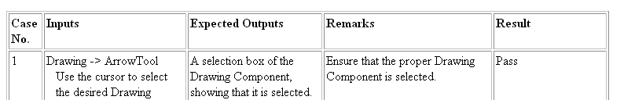
Figure 1: Matrix Column Headers

The Matrix is grouped into packages as shown in Figure 2. In this case the package group is File which may contain many classes.
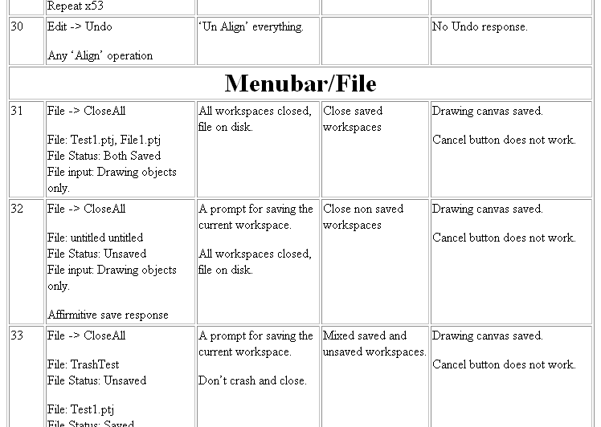

Figure 2: Example of QA Matrix

3 Testing Related Repairs

Some of the first test cases written were in the View class because of the simple nature of a lot of the methods which made experimenting with writing JUnit code very easy. This resulted in realizing some very specific limitation, not only on the system, but in a functional way. For instance, in the test case for zoomIn() and zoomOut(), I simulated a person clicking either the “Zoom In”, or “Zoom Out” button up to 1000 times. After reading the data that was returned, I realized that any number beyond 127 times would return incorrect results. This caused me to look deeper into the code to discover that the “zoom” variable used to hold the zoom level data was defined as a float type. Anything beyond 127 caused an overflow condition. In addition, any object zoomed in 127 times would be too large to be able to work with. Conversely, any object zoomed out 127 times would be way to small for any user to see. As a result of this, and looking at many other drawing tools, the code for this was modified to only zoom in, or out a maximum of 12 times like this:

if (cWindow.getZoom() > Math.pow(2.0, 12))

{

cWindow.setZoom(cWindow.getZom() * 2);

}

This example is typical of the constraint limiting problems found during testing.

3.1 Design Context

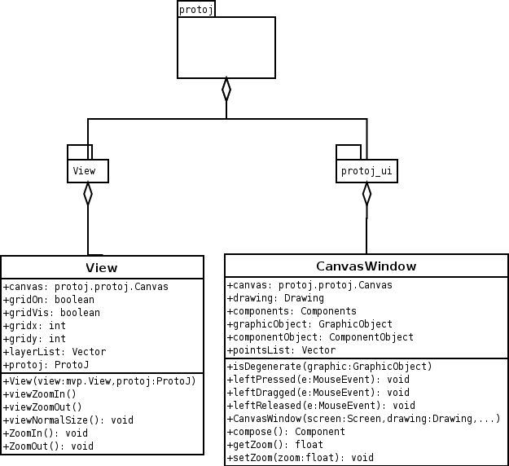

Figure 3: UML diagram

Figure 3 is a UML diagram showing the relationship between the packages and classes that received the majority of the testing.

Field and Method description for the View class

canvas is the local reference to the drawing canvas.

gridOn is a Boolean value representing if a grid’s drawing restrictions are set on.

gridVis is a Boolean value representing if a grid is visible on the canvas.

gridx is the x-dimension (or horizontal) spacing size.

gridy is the y-dimension (or vertical) spacing size.

layerList is a listing of layers for a particular Canvas object.

View() constructs the view object.

viewZoomIn()/ZoomIn() zooms in the image by a factor of 2

viewZoomOut()/ZoomOut() zooms out the image by a factor of 2

viewNormalSize() returns the view object and all components on the view object to its original size.

Field and Method description for the CanvasWindow class

canvas is a local reference to the drawing canvas.

drawing is a local reference to the upper-level Drawing object.

components is a local reference to the upper-level Components object.

graphicObject stores graphics as they are being created.

componentObject stores drawn components as they are being created.

pointsList stores intermediate points as a component or graphic is being drawn on the screen.

isDegenerate() checks a drawing to make sure there are no duplicate points suggesting an overlap of sides.

Method leftPressed(MouseEvent) is called by CanvasMouseListener when appropriate

Method leftReleased(MouseEvent) is called by CanvasMouseListener when appropriate.

Method leftDragged(MouseEvent) is called by CanvasMouseListener when appropriate.

compose(), Composes CanvasWindow by creating a new window.

getZoom() Returns the zoom value of this.window

setZoom(float zoom) Sets the zoom value to the given parameter

3.2 Example Repairs
An example of one fix is the Zoom In/Out feature. The equation to make the image zoom in is to take the image, and multiply by 2, essentially increasing the size of the image. The error was that instead of multiplying the image by 2, it was divided by 2 thus reducing the size by half. The corrected method is shown below.

public void viewZoomIn()
{
CanvasWindow cWindow = (CanvasWindow)(protoj.getProtoJUI().getCanvasWindow(protoj.getActiveWindowIndex())));
cWindow.setZoom(cWindow.getZoom() * 2);
}

public void viewZoomOut()
{
CanvasWindow cWindow = ((CanvasWindow)(protoj.getProtoJUI().getCanvasWindow(protoj.getActiveWindowIndex())));
cWindow.setZoom(cWindow.getZoom() / 2);
}

Another problem the drawing tool had was that if a drawing shape is resized such that any width was zero, the drawing degenerated and became unusable. The fix to this was to write a small method to check whether any 2 points were equal, thus indicating that 2 sides lie on top of one another. The method used to check whether 2 points lie on top of each other is “isDegenerate()”.

public void isDegenerate(GraphicObject graphic)
{
Vector points = graphic.getControlPoints();
for (Iterator pointsItr = points.iterator(); pointsItr.hasNext();)
{
Point point = (Point)pointsItr.next();
if (!point.equals((Point)pointsItr.next()))
{
canvas.addGraphicObject(graphic);
return;
}
else
return;
}
}

4. Code-Level Testing Framework

Typically, Code-Level testing is the lost art of writing small test scripts which in turn make calls to the methods you are trying to test. The old saying, “Code a little, Test a lot” was good advice, but took time to get a product to market. Nowadays, there is a push for better unit testing, and several companies, both commercial and Open Source have created testing packages to assist programmers in the “Code a little, Test a lot” idea.
NetBeans directly supported JUnit by integrating the test suite into the IDE, instead of having to run a standalone application. This allows you to

Creating the Testing Framework
Creating the Unit Testing Framework consisted of researching JUnit, a testing framework that is integrated into the NetBeans IDE. The idea of JUnit, is that every Class and included methods in a testing environment mirror their operational counterparts.

When JUnit is used to build the testing framework, JUnit creates a mirror of the existing directories and automatically creates the Class and Method stubs needed with the appropriate naming convention. Classes are named with the word “Test” appended to the class name such as “ClassNameTest”. Methods have the work “test” prefixed to the method name such as “testMethodName”. Below is an example test method used in ProtoJ.

public void testZoomIn() {

System.out.println("testZoomIn");

// TODO add your test code below by replacing the default call to fail.
while (x <= 12)
{
testView.ZoomIn();
CanvasWindow cWindow = ((CanvasWindow)(protoj.getProtoJUI().getCanvasWindow(protoj.getActiveWindowIndex())));
assertEquals(Math.pow(2.0, x), cWindow.getZoom(), 0.0);
x++;
}
}

Two methods are added to the stubbed-out test classes.
1. protected void setUp() is used to set up the environment common to all the methods in the class being tested. In this case, ProtoJ needs to be started like normal.
Specific setup calls needed only by the method being tested are called within the method stub.
The piece of code below is an example of the setUp() method used for ProtoJ testing.

protected void setUp() throws java.lang.Exception {

s = new Screen();
protoj = new ProtoJ(null);
protojUI = new ProtoJUI(s, protoj);
protojUI.compose();
protoj.setView(protojUI);
protojUI.show();

canvas = new protoj.protoj.Canvas(protoj, mvpView, 1);
drawing = new Drawing(mvpView, protoj);
components = new Components(mvpView, protoj);
keyListener = new ProtoJKeyListener(protoj);

testCanvasWindow = new CanvasWindow(s, canvas, drawing, components, keyListener, protojUI);
testCanvasWindow.compose();
}

2. protected void teardown() is used to return resources that was used during the testing of the class.

Unit testing individual methods is done by running the entire ClassNameTest. For every method under test, the setup() method is called to provide a freshly initialized copy of ProtoJ.

5 Testing Results

The current testing has already yielded several limitation not realized.

Zoom In/Out: Due to the datatype used, the number of times an image can be zoomed is limited to 127 times. This number is unrealistic in the sense that any image zoomed that number of times would be either invisible because it to small, or impossible to work on because it is too large. Current drawing programs limit the number of times an image can be zoomed in or out to approximately 4-6 times resulting in anywhere from an increase or decrease of size from 16x – 32x.

6. Online Project Repository

The entire ProtoJ project, including all of the testing work performed for this senior project, are available in an online CVS repository. At the time of this writing, the project is located here:

http://www.csc.calpoly.edu/~gfisher/projects/protoj

Readers can contact gfisher@calpoly.edu if the project cannot be accessed at this location.

Bibliogrophy

1. JUnit, http://www.junit.org

2. ProtoJ, http://waldorf.csc.calpoly.edu/~pavediss/protoj

