The Scheduler Project:
A Solution to
Manual University Scheduling

Prepared by:
Eric Liebowitz & Alexander Lindt

Special thanks to:
Jan Lorenz Soliman



California Polytechnic State University
December, 2010
Table of Contents
1. Introduction 4
2. Requirements 4
2.1 Functionality 4
2.1.1 No double-booking guarantee 4
2.1.2 Specifying Instructor's course/time preferences 4
2.1.3 An overall view of the schedule's “fairness” 4
2.2 Interface 4
2.3 Performance 5
3. Design 5
3.1 View: User Interface 5
3.1.1 File 6
3.1.2 Schedule 6
3.1.3 View 7
3.1.4 Database 7
3.2 Model: Schedule Generation 7
3.2.1 Generosity 8
3.2.2 ScheduleItems: The heart of the schedule 8
3.2.3 Double-Booking 8
3.2.4 Altering generating behavior 8
3.3 Model: Databases 9
3.3.1 Local vs. Global 9
3.3.2 Access within the Scheduler 10
3.3.3 Database Administration 10
Setting up the Database 10
Cloning the database 10
Changing database to be used at startup 10
Database Design 10
3.3.4 Schedule Preferences: What They Are 11
DaysForClasses (DFCs) 11
NoClassOverlap (NCOs) 11
3.4 Model: Schedule Evaluation 11
3.4.1 Statistical Details 12
3.4.2 Fairness vs. Quality 12
3.5 Model: Viewing Schedules 12
3.5.1 List View 12
3.5.2 Calendar View 13
3.5.3 Manual Editing: Not implemented 13
4. Testing 13
4.1 Approach: Random Metaprogramming 13
4.1.1 Testing language: Perl 13
4.1.2 Perl Modules for Java Classes 13
4.1.3 Modules for Testing 14
RandDataGenerator 14
Converter 14
RandClassGenerator 14
4.2 Constraint Verification 14
4.2.1 Output Format: Perl Code 15
4.2.2 Verification Module: ConstraintChecker.pm 15
5. Future Work 15
5.1 Schedule Generation 15
5.1.1 Alternate Day Combinations 15
5.1.2 Alternate DaysForClass Preferences 16
5.1.3 Equipment Preferences 16
5.1.4 Method of "Weighting" Preferences 16
5.2 Schedule Evaluation 16
5.3 Testing Design 16
5.4 Viewing Schedules 17
5.5 Manually Changing Schedules 17
6. Conclusion 17

Scheduler Project is software designed to automate the tedious and time-consuming process of scheduling courses for academic terms. This report documents the current status of the project – how it is designed; how it is tested – and details pertinent information about key features which have yet to be implemented.

The report covers all aspects of project development, including requirements specification, design, implementation, and testing.

1. Introduction

Our goal in designing this software was not just to create an algorithm to solve the classic scheduling problem, but to produce a production-quality product suitable for use in Cal Poly's Computer Science (CSC) department. It is designed to fit the needs of current scheduling administrators, providing with high-level features which allow them to easily mold the shape of the schedule. It also provides tools to make it easy to evaluate a schedule's quality amongst other contenders.

It should be noted that this document represents valid documentation for the Scheduler Project as it is now (Dec, 2010), but this project is still under development. Further changes in the following terms may invalidate some of the details given in this document.

2. Requirements

We interviewed professors and staff experienced with scheduling to define the features they found most useful. Our requirements can be found at http://scheduler.csc.calpoly.edu/requirements/. Key aspects of these requirements follow below.

2.1 Functionality
Three core requirements emerged which our software must satisfy. These are summarized as follows:

2.1.1 No double-booking guarantee
Two fundamental requirements that must be met by any course scheduling software are (1) never to schedule more than one course at the same time in the same room, and (2) never assign any single instructor more than one course at the same time

This guarantee was verified in our tests. See 4. Testing for more details.

2.1.2 Specifying Instructor's course/time preferences
Generating good schedules means trying to give instructors times and courses that they want to teach. This "instructor-centered" methodology guided key design choices for our algorithm. An explanation of this methodology can be found further within under 3.2 Model: Schedule Generation

2.1.3 An overall view of the schedule's “fairness”
Evaluating generated schedules by hand could easily become more burdensome than a manual scheduling system. Our software provides tools to analyze a schedule and rate it according to how closely it fits instructors' preferences and how many instructors had their preferences satisfied. See 3.4 Model: Schedule Evaluation for details on how this is accomplished, and what it means to the user.

2.2 Interface
Windows for generating and adding data are designed to use a common format, so that similar data-entry tasks are accomplished in similar-looking interfaces. Our specification outlines what our UI would look like through picture mock-ups. While these mock-ups are not exact representations of the interface, they illustrate how the software is to be used by the user.

Links to the documents which illustrate key features are:

- Adding Instructors: http://scheduler.csc.calpoly.edu/requirements/instructor-add.html
- Adding courses: http://scheduler.csc.calpoly.edu/requirements/course-add.htm
- Adding Locations: http://scheduler.csc.calpoly.edu/requirements/room-add.htm
- Generating Schedules: http://scheduler.csc.calpoly.edu/requirements/warmup.htm
- Viewing generated schedules: http://scheduler.csc.calpoly.edu/requirements/daily-course-view.html#daily & http://scheduler.csc.calpoly.edu/requirements/weekly-course-view.html#weekly

2.3 Performance
The project was designed to perform the bulk of its task effectively instantaneously, with two exceptions: add/removing items from a remote SQL database, and generating schedules of reasonable sizes.

Due to the unpredictable behavior of network connections, we could not guarantee an exact time constraint for database queries.

Schedule generation is guaranteed, in the worse case, to require time on the order of tens of minutes. However, during testing, schedules with large numbers of courses took less than 5 minutes to generate.

3. Design

Our projected implemented a Model-View pattern: classes responsible for the user interface (the “View”) communicate with other classes responsible for getting work done (the “Model”). We constructed our project around several key points of functionality:

- User interface – How the menu was presented; how windows were spawned, and from which class they all extended; Constructing a functional Observer-Observable link between the interface and underlying model. The javadocs for this model are helpful in understanding this design pattern. They can be found at http://download.oracle.com/javase/6/docs/api/java/util/Observer.html (Observer) http://download.oracle.com/javase/6/docs/api/java/util/Observable.html
- Schedule generation – Providing the important Schedule object and its equally important generate method
- Database interaction (both local and global) – Distinguishing between a remote database and local data, which could be saved to a file
- Viewing generated schedules – Providing functionality to view a generated schedule as a list, as well as viewing the schedule's appearance in a calendar-like format.

These points also define the primary packages included in the scheduler project (menu, db, generate, and view). With each of these packages, more detail and organization is designed using model/view, observer/observable, and other design patterns.

The root of our Javadocs can be found here: http://scheduler.csc.calpoly.edu/API.

3.1 View: User Interface
Our program is normally invoked with a simple menu bar. Below is a description of each option it presents: special attention will be given later to the more fully implemented options.

- File
  - Responsible for saving/opening schedules, along with gracefully closing the program
  - Partially implemented – Only “Save”, “Open”, and “Exit” operations work
- Edit
  - Provides standard options to Copy, Cut, Paste, Select All, etc.
  - Not yet implemented
- View
  - Supplies the user with options to configure how a schedule is displayed
  - Partially implemented – View options do not work
Figure 1: Menu Package

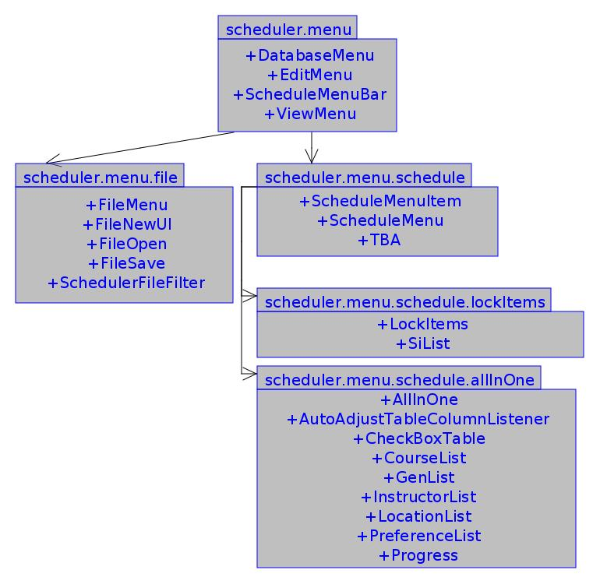
Handles all functionality (model & view) related to the menu bar.
- Schedule
  - Lists actions to add/edit local data which is used for schedule generation
  - Allows user to analyze a schedule's fairness
  - Home of the “Generate” command option
  - Partially implemented
- Database
  - Similar to the Schedule menu: provides options to add/edit/remove data from the global database
  - Fully implemented

The classes responsible for defining windows for these commands are all located under the scheduler.menu package.

Where appropriate, these menus were given packages of their own, in order to tightly organize which classes were responsible for what functionality. See the package diagram in Figure 1.

Once a schedule is generated (or a data file is opened via the File menu), the menu bar expands in its window, displaying a generated schedule beneathe the menu.

3.1.1 File
Three options are supported in this menu: Open, Save, and Exit. The former two options only list files with the extension “.sdf” (Scheduler Data File). The Save feature behaves more like a Save As option: every time the user selects “File-->Save”, she is prompted for a filename to which to save your local data.

3.1.2 Schedule
This menu is devoted to local data manipulation and generating schedules based on said data.

The Courses, Instructors, Locations, and Preferences option spawn windows to add/edit/remove the data each menu represents. For more information on the details of this data, see the 3.3 Model: Databases.

The Schedule, Lock Items, and Change Hours options do not spawn windows, since they have not been attached to the underlying model in any meaningful way. Schedule allows the administrator to modify basic information about the schedule (the quarter it represents, phase of its development, etc). Lock Items allows an administrator to lock certain parts of an already-generated schedule. These locked items are preserved when a new schedule is generated, using the previous schedule as the starting point. Change Hours would allow the user to set the bounds for schedule generation (i.e. when the “day” officially started/ended).

TBA's (To Be Announced) are schedule entries for any course/instructor combinations which could not be given a location during generation. If none exists or no schedule has yet been generated, it displays a dialogue to tell the user that no TBA's yet exist.

All-In-One might better be named “Generate”, but previous requests by our advisor, Gene Fisher, put it this way. This will spawn the window responsible for deciding what will be included in generation, along with actually executing the “generate” command.

3.1.3 View
Contains options to change how the schedule is viewed – by Course, Location, or Instructor. The default view is by Course. Other views are not currently supported. An option for “Advanced Filter” allows the user to configure each view (start time, days displayed, etc). Currently, this is not supported.

Provides commands to view the “fairness” and “quality” measurements for a schedule. See 3.4 Model: Schedule Evaluation for details on their meanings.

Much of this menu's view is not hooked up to the corresponding model because the code is no longer reliable. See 5.4 Viewing Schedules for details on how this might be fixed

3.1.4 Database
This menus provides commands that allow a user to modify entries in the remote SQL database. The Courses, Instructors, Locations, and Preferences create windows very similar to those under the Schedule menu.

The Sync command allows the user to copy all data in the local database into the global database, and vice versa. This makes it easier to take a schedule with good data and upload its useful data to the database, where it could be accessed globally. Conversely, it also allows a user to revert back to a “base” set of data in the database, from which all schedules can be derived. This feature is implemented, but untested; using it may yield unpredictable results.

3.2 Model: Schedule Generation
Generation is done in an “instructor-centered” way, using a greedy, heuristic-based algorithm to create schedules which are desirable to as many of the instructors as possible. This “instructor-centered” method focuses on satisfying an instructor's time and course preferences at every decision point, omitting any choice which the instructor cannot accept (that for which a preference of 0 has been specified), and sorting any other choices in descending order of desirability.

The algorithm has 3 primary steps, applied to all instructors in a revolving order, as the following pseudo-code describes:

while (list of Courses not empty)
for each Instructor “i” (sorted by generosity)
Choose Course “c” which “i” most desires to teach
Compile list of times “i” can teach “c”, in descending order of desirability
Choose a location which is available for the most desirable time and which provides for a course's equipment needs (if any)

Compile the course, time, and location into a “ScheduleItem” to add to the schedule

Since the algorithm is greedy, it has no easy means of detecting whether a given time will be available, though an instructor may have specified a high preference for it. Thus, a list of acceptable times is created. In the event that no location exists which satisfies an Instructor's most desired time, the next-most desired time will be used. This process continues until a location is found which most closely fits the instructor's availability preferences.

Note that a list of locations is not created: only a single, acceptable one is chosen. Choosing a location for each available time increased generate-time exponentially (especially if the course scheduled had a lab). A future feature might be to allow instructors to specify which equipment they want their lecture/lab rooms to provide. If this were to happen, it might prove beneficial to generate a list of desirable locations. See 5.1.3 Equipment Preferences.
Figure 2: Generate Package

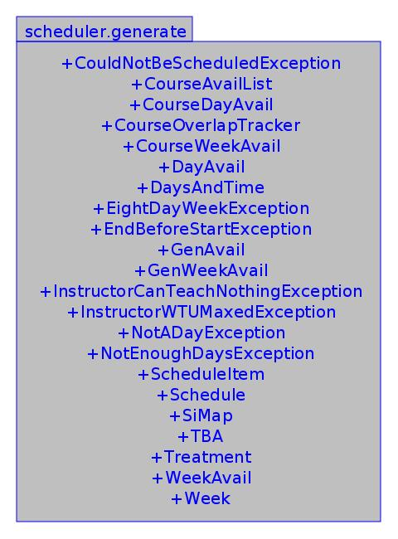
Contains all classes/exceptions for generating schedules

3.2.1 Generosity
Instructors are sorted in ascending order in terms of “generosity”: how many “things” (times/courses) they have specified as desirable (i.e. what will make them “happy”). The more things available to make an instructor happy, the higher his generosity rating. Thus, instructors who are very greedy (not generous) are chosen first, in the hope that the few things which will make them happy are available for them immediately. More generous instructors will follow later, as it is likely something desirable will still be available for them when their turn comes.

This heuristic risks treating greedy professors too well, stealing possible “good” courses/locations from instructors who were more generous and serviced later in the scheduling loop. An administrator can manually tweak a too-greedy or too-generous instructor's preference to mitigate this problem.

The fairness evaluation helps an administrator to see such problems. See 3.4 Model: Schedule Evaluation.

3.2.2 ScheduleItems: The heart of the schedule
At its core, a schedule is merely a Vector of scheduler.generate.ScheduleItem (SI) objects. This object holds all the information necessary to place it on a published schedule, along with analyzing its value to the Instructor it applies to. It holds information regarding:

- The instructor teaching it
- The course (and section) it represents
- The day(s) and times it will be taught
- Its corresponding lab (if applicable; also an SI)
- Its “value” to the instructor (based on said instructor's time/course preferences)

During generation, hundreds of SI's are generated for each instructor every time he is given a course to teach. Specifically, a new SI is generated for each time range he is available. In order to perform necessary sorting during schedule generation, the SI provides a getValue method, which returns a double representing how valuable it is to its instructor, with higher numbers being more valuable.

Sorting of these among ties is not defined.

3.2.3 Double-Booking
HashMap's are used to ensure that locations and instructors are never double-booked. They are keyed by Location and Instructor objects, respectively, and yield scheduler.generate.WeekAvail values. In the event that a ScheduleItem is generated which creates a double-booking, it will not be added to the schedule.

Currently, no visible error is given to the user when this happens. This is because, as the code is written, double-bookings should never even be generated. This particular "should never" requirement is one of the most important aspects of the specification, and forms a key focus of the testing strategy outlined in 4. Testing

3.2.4 Altering generating behavior
The algorithm makes its decisions based on two factors: instructors preferences, and over-arching schedule preferences. Tweaking an instructor's preferences can help to give him different courses/times. Creating/changing schedule preferences can alter the entire form of the schedule. See 3.3.4 Schedule Preferences: What They Are for more details.

3.3 Model: Databases
Figure 3: Database Packages

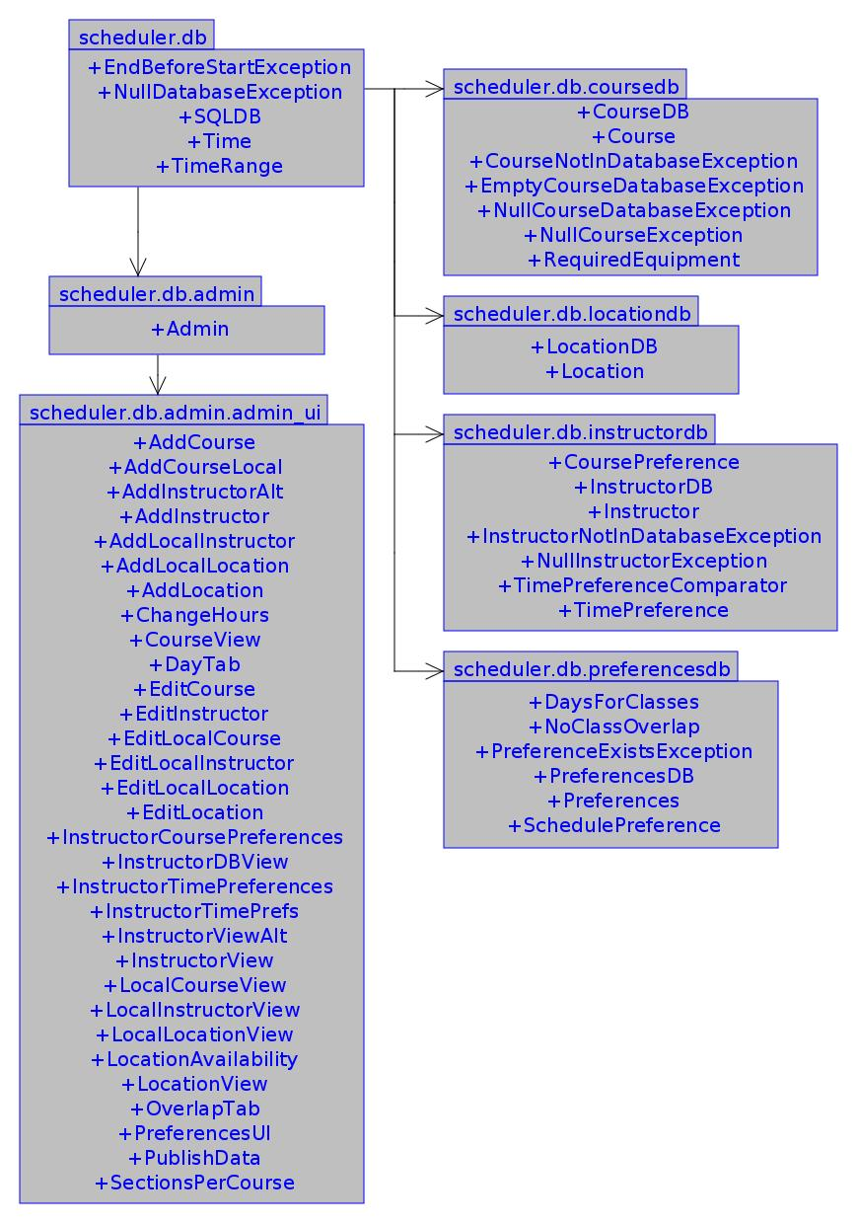
Handles local/remote database administration
The project has two databases: (1) a remotely accessible SQL database (referred to as “global”), which serves as the base of all schedules; (2) a local database, which can be saved to and opened from a file (“local”). Each of these databases contains information regarding the following pieces of scheduling data, each of which is often referred to as its own, individual database:

- Courses (CDB) – What must be taught in a generated schedule
- Instructors (IDB) – Professors available to teach courses
- Locations (LDB) – Classrooms available to have lectures/lab taught
- Preferences (PDB) – Guide the scheduler's decisions, such as deciding which courses cannot overlap one another

Manipulating the local/global version of any of the above databases is done via their own, single object. Thus, 4 objects – one for the CDB, IDB, LDB, and
PDB – control the local and global properties of the databases they represent. Appropriate getters/setters for local/global data are explicitly defined in each class.

For information on the finer details, the reader may peruse the javadocs for these classes here: http://scheduler.csc.calpoly.edu/API/scheduler/db/package-summary.html.

3.3.1 Local vs. Global
The local database is what schedule generation looks at when its generates schedules. It also holds the data which is saved to/opened from with the Save and Open operations, respectively. Thus, the local database is the “working copy”.

When the program is started, a copy of the global database is put into the local, effectively cloning the data. Thus, the global database acts as a “base” upon which all other schedules will work. Hence, this database holds instructors' generic, infrequently-changing time and course preferences. This also allows for exceptional changes to be made to a single schedule without breaking the mold by which all other schedules go. If the program is unable to connect to the global database at runtime, the local database is initialized empty.

3.3.2 Access within the Scheduler
Our program is only capable of opening one schedule at a time. Thus, there is only one database to access at any given time. To make accessing this data easier, public, static fields are defined in the scheduler.Scheduler class. Any class which needs them can access them directly or, since we later discovered that public fields are dangerous, use the provided “getters” in the scheduler.Scheduler class. (Getters/setters also exist for the local versions of each database).

3.3.3 Database Administration
While much of our project is based in Java, we made prevalent use of MySQL to manage our remote data. The following descriptions will help to familiarize you with how our databases run and can be managed.

Setting up the Database
In the source code there is a folder named database setup. In the database setup folder there exists a file named start.sql. In order to do the initial setup, you must run the following command, where username corresponds to a username and password for a user that can access the mysql database.

mysql -u [username] -p[password] < start.sql

Cloning the database
In order to clone the database on the same mysql server you must first create an empty database with the desired name. This can be done by following these instructions:

- Enter the mysql command line by using the following command:
mysql -u [username] -p[password]
- Use the following MySQL command to create the database:
mysql> CREATE DATABASE [Database Name];
- Return to the terminal and run the following command:
mysql -u [username] -p[password] [Database Name] < clone.sql

Changing database to be used at startup
The default database connection can be changed. In order to do this you need to pass in a command line parameter to the jar file. The following command shows how this is done.

java -jar scheduler.jar mysql://[URL]

For example if the server is at abc.homelinux.net/ and the database name was test then the following command would connect to that database.

java -jar scheduler.jar mysql://abc.homelinux.net/test

Database Design
The database was designed to mirror our implemented java classes. Thus the database fields all correspond to the instance variables of the objects they are modeling.

For example, the Location class consists of a building, a room, the maximum occupancy, the type (lecture, lab), the equipment it provides (overhead, projector, etc.) The table describing the Locations has fields for all of the above instance variables.

The one difference is the relationship between courses and preferences. Courses and preferences are mapped in a many-to-one-relationship: each course can have one day preference. Each day preference can be mapped to multiple courses. When a course or preference is deleted, rather than searching the other table for the corresponding ids, the scheduler can just look in the courses_to_preferences table. This table maps course ids to preferences.

3.3.4 Schedule Preferences: What They Are
Schedule preferences work to guide decisions made during schedule generation in a more broad sense than an individual instructor's time/course preferences. They apply to the entire schedule. While a “weight” field can be applied to them, it is currently not taken into consideration: created Schedule Preferences are considered “law” by the scheduler: it will no more break them than it will double book a room.

Currently, two preferences are supported. Ironically, only one applies generally to schedule generation. They are both located under the scheduler.db.preferencesdb package.

DaysForClasses (DFCs)
These preferences attach to courses, dictating which days of the week they will be taught (Mon-Wed-Fri, Tue-Thu, etc.). If a course has a MWF DFC, an instructor's time preferences for only Monday, Wednesday, and Friday will be checked when finding times to teach that course.

This preference exists to give the user more control over the form of the schedule. Simply letting instructor preferences dictate how a schedule is formed could prove disastrous, as they may not prefer to teach in a pattern conducive to scheduling (i.e. instructors could all really want to teach only on Monday and Tuesday). While an administrator could manually tweak the instructors' preferences, this could prove more time consuming then necessary. With DFCs, he can work to force courses into certain places, letting an instructor's preferences come second.

Future versions of the schedule might improve the generating algorithm to see which courses have DFCs which are desirable to an instructor. However, this is not yet part of the scheduler's functionality.

NoClassOverlap (NCOs)
If two courses are often taken together in a given academic term, it would be counterproductive to allow them to overlap on the schedule: students would not be able to attend both. NCOs allow a user to specify which courses he does not want to overlap with one another.

Courses in the same NCO will essentially block one another from time slots. If courses A, B and C are in the same NCO, and A is scheduled for 8a-9a on MWF, neither B nor C can ever occupy that time slot (though other sections of A can).

3.4 Model: Schedule Evaluation
Fairness is the quantitative measure of how closely an instructor's time preferences were upheld in the generated schedule. This value can range from zero to ten, where zero is the least fair, and ten is the most fair. Statistical analysis is used on these values and the results are displayed to the user. This allows the user to easily discern to what extent an instructor's time preferences were upheld in relation to others. This can help expose instructors who were favored too little or too much.
Figure 4: Fair_Qual Package
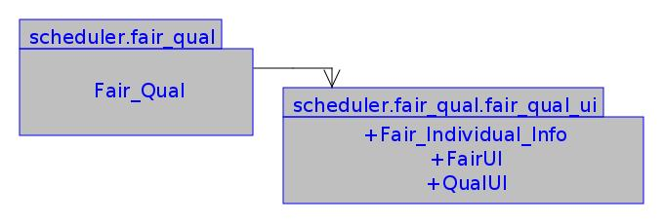

Rates the schedule's “fairness” and “quality”

Generating fairness relies on an instructor's time preferences. For each time slot that the instructor is scheduled, her fairness value is the same as her preference value for that time. (If assigned to teach for a time with a preference of 7, the instructor would have get fairness value of 7). The final fairness value for each instructor is the average of these individual fairness values.

3.4.1 Statistical Details
Basic statistical values such as the mean, median, lowest/highest values, and standard deviation are generated to judge a schedule. Using every instructor's fairness value, we create a standard normal distribution using the mean and standard deviation. Any instructor with a fairness values further than 1.65x standard deviations from the mean is considered to be an outlier. Outliers in this situation are instructor's whom are treated within either the top 5% or bottom 5% of the distribution. A list of all outlying instructors and all of the values that led to their overall fairness value are formed for consideration from the administrator.

Since our project is ongoing, actual usage feedback may change the statistical definition of outlier, based on how large the lists of outlying instructors are for typical scheduling runs.

3.4.2 Fairness vs. Quality
Two methods of rating a schedule are supplied: (1) fairness rating defined with respect to instructors' preferences; (2) quality rating designed with respect to adherence to schedule preferences.

Our requirements specificied that weights attach to schedule preferences to asses schedule quality. However, our algorithm does not take these weights into consideration during generation: it simply takes each preference as law and refuses to violate them. Thus, rating schedule quality is pointless.
See 5.1.4 Method of "Weighting" Preferences & 5.2 Schedule Evaluation for details on how the lack of “quality” measurements might be resolved.

3.5 Model: Viewing Schedules
Our project provides to methods by which to view a generated schedule: a day(s)-of-the-week, calendar layout, and a linear, sorted table layout. The views automatically expand/update when a schedule is generating, defaulting to a list view if the user is not currently viewing a schedule.
Figure 5: View Package

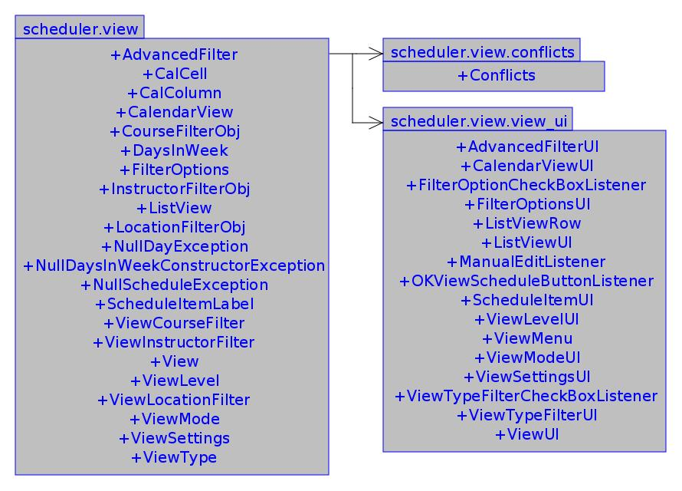
Handles model & view related to viewing schedules.

Both views are “stable”: they work with the supporting classes around them. However, no attention has
been given to them despite the refactoring done to much of the rest of the project. In particular, they (unfortunately) depend on public fields of other classes (such as the ScheduleItem).

These view are in desperate need of re-factoring. See 5.4 Viewing Schedules for details on what needs attention.

3.5.1 List View
This view presents each ScheduleItem as a single row entry. Data viewed can be specified by a
number of filters. Columns can be rearranged. Sorting according to various values is not supported.

3.5.2 Calendar View
This view displays ScheduleItems across a calendar-like view, allowing a more pictoral representation of the schedule.

3.5.3 Manual Editing: Not implemented
The requirements specification describes a mechanism by which a user can change the schedule, dealing with any conflicts he may create. However, our implementation of the project does not support this feature. The user cannot change any part of the schedule by hand. Changes can only be facilitated by regenerating a schedule after changing instructor's teaching preferences.

See 5.5 Manually Changing Schedules for details as to what implementation would entail.

4. Testing

To verify the project's integrity, we narrowed the requirements of a generated scheduled to constraints: laws by which every schedule must adhere. Two constraints were identified as essential to schedule generation

- Double booking – no instructor would be scheduled to be in two places at once; no location would be scheduled to hold two (or more) classes at once
- Preference respect – instructors who give a preference of 0 for teaching a course or during a given time interval mean to say “it is impossible for me to do this”. Thus, no ScheduleItem in a generated schedule should give an instructor something which he is physically incapable of doing.

With so many variables to consider during generation, hand-generating test schedules would be both time consuming and inefficient: It would be prohibitively time consuming to create enough combinations of factors to ensure the scheduler's constraint-adherence.

NOTE: This testing documentation is valid for the 2010 (Dec) release of the project. Usage has shown this method to be inefficient and impractical. See 5.3 Testing Design for details of a new testing approach.

4.1 Approach: Random Metaprogramming
We implemented an automated test-case generator which generates Java files to populate a scheduler.Scheduler object with systematically varied Course, Instructor, and Location information and generate a schedule. Once generated, each scheduler.Scheduler dumps its vital data to a file, to be verified later by an external program.

4.1.1 Testing language: Perl
Perl's provides excellent functionality for manipulating text and easily storing data in hashes. Combined with a random data generator, spawning data to populate schedules proved fairly simple. The ease with which Perl can utilize external modules and work both as a procedural and object-oriented language helped to mimic our project's internal data, making data generation easier.

4.1.2 Perl Modules for Java Classes
Each piece of data generated fits with the Perl object it is to be instantiated as. In other words, information regarding a Course object (from the Scheduler) will be output in such a way as to be easily parsed by the constructor for the Course module in Perl. The following modules are provided under testing/implementation/source/perl/plib to mimic in Perl how Scheduler data is represented in Java:

Perl Module Mimicked Java Class
- Course.pm scheduler.db.coursedb.Course
- Instructor.pm scheduler.db.instructordb.Instructor
- Location.pm scheduler.db.locationdb.Location
- ScheduleItem.pm scheduler.generate.ScheduleItem
- Time.pm scheduler.db.Time

4.1.3 Modules for Testing
In order to effectively generate Java files which can populate a scheduler.Scheduler object, several modules have been created to break up the work of data and class generation. The most important modules are discussed here.

Each Perl module/class detailed is located under the following directory, relative to the root of our repository: testing/implementation/source/perl/plib

RandDataGenerator
This module is object oriented, in order to allow extension of it by children classes to customize how data is generated, if future developers ever need to do so.

Given a number of courses, instructors, and locations, it randomly generates data for these three data structures, dumping each into a separate text file (provided by the user). The formatting of these text files is important, since they must be Perl-readable. (To this end, the Data::Dumper module is used to output data, as it prints in Perl-readable syntax).

Each of these files are later parsed and run in a Perl eval block (the string version), in order to pass the generated data on to other stages of the testing process. In particular, each piece of data dumped is the data for a single Course, Instructor, or Location Perl object, stored as a hashref, and eval'd as one.

Converter
Given the three files generated from RandDataGenerator (for courses, instructors, and locations), takes the data they hold and generates a Java class. This generated class instantiates a scheduler.Scheduler object and populates its local databases with the information from the three generate information files.

It is an object-oriented module, in order to allow other developers to customize the most important part of this module: what it says the main method of its generated class will do (via the method whatMainDoes). By default, this class simply calls the generate method, followed by a call to the Scheduler's “dumpAsPerlText” method.

RandClassGenerator
This is an object-oriented convenience class. It wraps up the RandDataGenerator with the
to allow a user to easily generate Java files to populate Scheduler objects with random data.

This module is backed by its parent class, ClassGenerator. It extends it by creating its own data with the RandDataGenerator before converting it to a Java file.

4.2 Constraint Verification
After schedule's are generated, a special method is called in the scheduler.Scheduler class: dumpAsPerlText(PrintStream ps). The provided PrintStream points to a file. (It could point anywhere, such as STDOUT, but these methods were designed for file dumps). This method, in turn, calls similar methods on the pieces of the schedule necessary to verify constraint adherence. In particular, the following classes output their information:

- The local instructor database (including all instructor's preferences)
- The generated schedule (its list of ScheduleItems)

With this data safely stored in a file, another Perl module is called to peruse the file and verify the schedule's integrity.

4.2.1 Output Format: Perl Code
As with the files generated in the RandDataGenertor module, text dumped from the Scheduler must be formatted as Perl code, as it will later be eval'd to reconstruct the data in terms Perl can understand. In particular – since Instructor and ScheduleItem data is output – the data must be output in a format readable by the Instructor and ScheduleItem Perl Modules. The output file will provide the information for constraint checks.

For clear data separation, Instructor data is contained between the tags "--LOCAL IDB BEGIN--" and "--LOCAL IDB END--". Schedule data is between the tags "--SCHEDULE BEGIN--" and "--SCHEDULE END--". Individual pieces of data are delimited with the token "===".

4.2.2 Verification Module: ConstraintChecker.pm
This single module, located under testing/implementation/source/perl/plib, performs any and all tests on the data output from the dumpAsPerlText method in the scheduler.Scheduler class. This dumped data is reconstructed as Perl data. By centralizing all testing here, it is easy to add more tests: simply supply another function to be called by the module in its check function.

Currently, this module performs the following tests. Their methods of implementation are detailed as well.

- Verification of no double bookings
  - Hashes are used for ensuring instructors/locations are not double booked. Each hash yields another hash, keyed by hours, which yields another hash keyed by minutes. For each time a given item is booked, the appropriate hash key is incremented by one. Thus, any hash key whose value is greater than one represents a time which has been used twice: a physically impossible feat to achieve.
- Time/Course preference respect
  - Every ScheduleItem's Course, Times, and Instructor are used to verify that no Instructor has been given a course/time which he specified a 0 preference for. Methods provided by the Instructor.pm module make it easy to look up preferences for courses/times.

ConstraintChecker.pm utilizes the Test::More module (part of the Perl 5.10 core distribution). Each test run (whether checking for double booking or preference respect) is done with a single call to "ok()". Each test is given a small string to print, describing the test. Failed tests display useful debugging information along with the test string, so as to make finding errors easier.

The module does not call "done_testing()", allowing other testing scripts which use Test::More to not balk when they try to create a test plan or call "done_testing()".

5. Future Work

Though in working order, our project is by no means finished. Many features remain unimplemented, insufficiently tested, or in need of re-factoring (including some of the tests). These holes in the project are the places to target for improvement in subsequent versions of the tool, either by our team or others who follow.

5.1 Schedule Generation

5.1.1 Alternate Day Combinations
Course DaysForClass (DFC) preferences are not arranged in alternate combinations. For instance, given a course with a MWF DFC. Our algorithm will only consider three obvious combinations of these days: MWF, MW, and M.

To address these issues, the following three methods would be a good place to start working. They are located into the scheduler.generate.Schedule class:

- createDatsForDays
- getAllDayCombos
- chooseWhichDays

5.1.2 Alternate DaysForClass Preferences
In some cases, it could prove useful to say to the scheduler "Try and schedule this course for MWF. If that doesn't work well, try a TR combination, or a MTRF". Currently, the scheduler only lets the user specify one DFC for a course. By providing a list, prioritized in order of most desired, a user would be able to provide the scheduler with "backup plans", which could turn out to generate a better schedule once considered.

For example, suppose no particularly "good" times exist for an instructor on MWF for a course she really wants to teach. If there were a backup TR DFC, where a wealth of high time preferences existed, the instructor would be given better times (i.e. be treated more fairly).

5.1.3 Equipment Preferences
Our original specification required the project to allow courses to require certain locations to provide various equipment (overhead, laptop connectivity, etc.). While our program does this, is has become unnecessary: no course requires much of any equipment. If they do in future usage cases, the functionality to ask for it exists.

In addition to courses requiring equipment, we found the professors often like their lecture/lab rooms to have equipment. Future versions of the scheduler could allow a professor to specify equipment preferences, which would affect where he is placed to teach a course during generation.

A method in the scheduler.db.Instructor class would be needed to get the desirability an instructor has for a particular course. This method would then need to be utilized in the scheduler.generate.ScheduleItem's "getValue()" method.

5.1.4 Method of "Weighting" Preferences
Though you may specify a "weight" for NoClassOverlap preferences (NCO's), it isn't considered during schedule generation.

This weight was to be used to give our algorithm the question "How worth it is it to break this preference?". Higher weights would make it less worthwhile to break (i.e. more important; law-like).

Ideally, a dynamic algorithm would be able to determine which decision (break or upholding a preference) yielded a better results. However, in the interest of time, our greedy, heuristic-based scheduling algorithm was used instead. Incorporating a method by which to consider these weight could be an improvement on our algorithm. However, treating preferences as “law” could just as well be a worthy method handling them.

No methods/classes consider a preference's weight. No facilities currently exist to accommodate them.

5.2 Schedule Evaluation
Though our evaluation algorithm might be theoretically sound, it is not implemented (neither for “fairness” nor “quality”). Our original algorithm was implemented based on legacy code written before several re-factorings of our algorithm and supporting classes. An obvious area of improvement would be to implement these statistical algorithms in order to give the user a meaningful way to assess a schedule's worth.

5.3 Testing Design
Tests require the generation of thousands of separate Java files, each with systematically varied data to populate local databases. This incurs too high a claim on disk space to be feasible (> 15 GB), and represents a substantial amount of testing time.

A new test design will be implemented. A single Java class will be used. At run time, the class will be provided with four parameters to guide how it builds a test: (1, 2, & 3) how many courses, instructors, and locations to use; (4) what to name the file to output testing data. Like the current, Perl version, it will create schedules and dump their contents to files. Unlike our current tests, it will only require this single Java file. The tests will only need to invoke said class with different parameters.

This implementation will remove the cost of test-class generation and reduce tests' compile time to nil.

5.4 Viewing Schedules
Code for viewing generated schedules (both Calendar and List mode) is in need of major refactoring. It depends on public fields in numerous other classes, all of which have changed their internal representations since the View's functionality was defined. Furthermore, many classes have had to retain old, outdated fields to maintain the view's functionality.

The classes for this scheduler.view package were written with the use of a GUI builder (NetBeans), but the program-specific files used for configuration are not stored in our repository. A full rewrite of the classes may be necessary to improve functionality of the view. While not immediately necessary, doing so might prove most beneficial to the user, as a fully-functional GUI can go a long way.

5.5 Manually Changing Schedules
Allowing the user to reach in and change a generated schedule would require two primary features: (1) detection of and notification to the user of conflicts created, such as double-bookings; (2) Means by which to easily see which instructors are currently still available to teach, so an administrator can easily see places where a schedule has room to bend.

These features would not be easy to implement. While fields in the scheduler.generate.Schedule class would make it easy to check if manual edits created conflicts, no other facilities exist to accommodate this feature.

6. Conclusion

Though in working our, the Scheduler Project is still under development. Maintenance and functionality requests will be supported at least through the Winter 2011 academic term. Points mentioned in Future Work will be addressed, including 5.1.1 Alternate Day Combinations, 5.2 Schedule Evaluation, and 5.3 Testing Design.

Additionally, a feature not present in the requirements will be researched and possibly implemented: the ability to take a schedule and “publish” it to Cal Poly's catalog of academic schedules. Interviews with scheduling administrators revealed this as a very useful feature for the project, as the manual entry of data into Cal Poly's system can take as much time as drafting schedules by hand.

