Timothy Ober
Senior Project Writeup
06 June 2006

1. Problem Description:

The purpose of this project is to build the dataflow diagramming tool, called "dftool". The tool provides functionality for drawing and editing dataflow diagrams (DFDs). It also supports the translation of DFDs to and from their textual representation in a formal modeling and specification language (FMSL). Some basic requirements for dftool are presented in the users manual for a previous implementation of RSL support tools (falcon.csc.calpoly.edu/home/gfisher/projects/fmsl/subprojects/dftool/documentation). Sections 7 and 8 of that manual discuss features of the dataflow editing. The set of tools described in the old manual were implemented in C and C++ to run in an X Windows environment, and are not portable to other platforms. A key objective of the current dftool project is to design and implement a multi-platform version of the dftool in Java. Initially, the Java-based dftool will be a stand-alone application. At some later point, it may be integrated into an Eclipse environment for FMSL. The requirements presented here refine and extend the earlier tool’s features. Particular new features of note are the
following:
a. The new dftool can operate as a fully stand-alone application, in addition to operating as a component of a larger integrated FMSL development environment; the requirements here focus on its stand-alone interface.
b. These requirements have significant enhancements for the connectivity of dataflow nodes in a diagram, in particular the explicit display of input/output ports, and incremental validation of inter-node connections.
c. The FMSL textual representation of a dataflow diagram has been enhanced since the implementation of the earlier RSL-based tool. These new requirements describe the formal mapping from a graphical dataflow diagram to its underlying FMSL specification.

2. Scenario of Use:
When the program begins, the menu bar will appear.
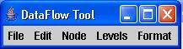

To begin a new session, select File->New Diagram.
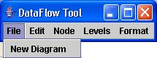

This will cause a new GraphFrame to appear.
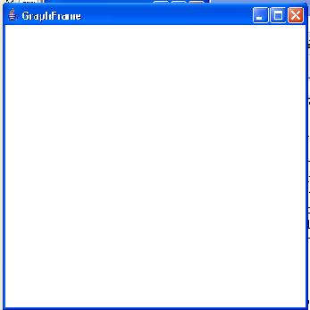
To create a new node, select the Node->New Node toggle box, and click within the GraphFrame.
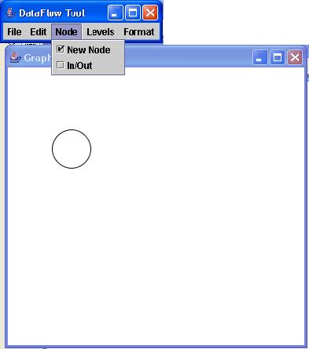
New nodes will appear each with each click in the GraphFrame until the Node->New Node toggle box is selected again. Once more than one node has been created, deselect the Node->New Node toggle box, and select the Node->In/Out toggle box.
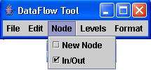
To create an edge between two nodes, with the Node->In/Out toggle box selected, click on the originating node, then click on the destination node.

To create an input port, with the Node->In/Out toggle selected, click on a clear space on the GraphFrame, then click on the node that will receive the input port (the bottom node, in this case). To create an output port, click on the node to receive the output port (the top node), then click on a clear space on the canvas.
To connect two ports, with the Node->In/Out toggle box selected, click on one port, and then click on another port; one port must be an output port, and one must be an input port, and the two ports must have the same label. If this is not the case, the second port will turn red, and an edge will not be created. To create an edge from a port to a node, or from a node to a port, with the Node->In/Out toggle box selected, click on the originating node or port, then click on the destination node or port.
To Levelize part of a graph, click an empty place on the GraphFrame, and drag a selection box around a set of nodes.
Then select Levels->Levelize.

This will cause another GraphFrame to appear, which has the set of selected nodes. The existing GraphFrame will have the selected nodes removed, and replaced with a new node that represents the selected nodes that were levelized. Edges between levelized nodes will be copied. Edges between levelized and non-levelized nodes will become ports in the new GraphFrame, and become edges attached to the new node in the existing GraphFrame.
To add control points to an edge to control that edge's shape, select the
Format->Edge Shape->Add Points toggle box, then, click on an edge.
Deselect the Format->Edge Shape->Add Points toggle box. Then, click and drag the newly created point to change the shape of the line.
To delete points, select the Format->Edge Shape->Delete Points toggle box. Then, click on a point that is not an endpoint to remove it.

To show and hide node, edge, and port labels, select the appropriate toggle box from the Format menu.
To edit a label, click on that label, and it will become highlighted. Typing will add characters to the label, and the backspace key will delete them.
3. High Level Design:
The DataFlowRunner is a JFrame, and contains the menu shown in the Scenario of use. It contains a list of GraphFrames which are PFrames (Piccolo Frames) in order to apply menu changes to every GraphFrame.

Each GraphFrame contains a list of PNodes, from which DFEdges, DFEndpoints, and DFLabels derive. However, only DFNodes and DFEdges are ever added directly to the GraphFrame; DFLabels and DFPorts are referenced in the DFNode or DFEdge they belong to. GraphFrames also contain a variety of listeners, implemented as inner classes, to control the movement and editing of their children.

DFEdgeHandles and DFEdgeEndpointHandles are used to control the shape and position of DFEdges. The SetXYLocator (Locators are used by Piccolo to control the positions of handles) just returns the X-Y location of the handle it is attached to. DFEdgeEndpointHandles use their reference to a DFEndpoint to positon themselves.

4. Design and Implementation Details:
The Piccolo 2D graphics tool set (http://www.cs.umd.edu/hcil/jazz/) was used to create this project. Piccolo is very similar to Java Swing in many ways, but has some significant differences. Difficulties encountered with the Piccolo tool set are listed below.
4.1 Scene graph vs. screen coordinates
Piccolo uses a scenegraph methodology similar to Java3D, in which all children inherit the transforms of their parents. This makes transforming composite objects very easy. However, Piccolo's position finding functions do not work well with their scene graph transformations. When an object is translated, rotated, or scaled, it's position is not updated. For example, a PNode on which setX(0) has been called, which is then modified by a call to translate(10, 0) will in some cases still return 0 when getX() is called. I have not investigated this aspect very thoroughly, but chose instead to implement my own updating of children using screen coordinate changes, rather than transforms.
4.2 Labeling/text class PStyledText
The class PStyledText seems like it could be very useful, but I have not been able to make it work independently of the PStyledTextEventHandler, which seems to be extremely limited. These seem to be very powerful tools, but are poorly documented, and difficult to modify.
4.3 Listeners
Piccolo listeners, specifically the PBasicInputEventHandler, sometimes have issues when they interact with other listeners. First, the programmer should remove the Pan and Zoom listeners from the canvas, as they will register almost every hit anywhere, and often will preempt other listeners. Second, some functions, such as mouseDragged and mouseClicked, will sometimes interfere with each other when placed in the same listener.

5. Related Work:
Some tools for creating dataflow diagrams already exist, such as ConceptDraw V (http://www.conceptdraw.com/en/products/cd5/main.php) or Flow Charting 6 (http://www.patton-patton.com), but these cost $149 and $159 respectively. The program called SHriMP (http://www.thechiselgroup.org/shrimp Also known as Creole as a plugin for Eclipse, and Jambalaya as a plugin for the Protege tool) also has some dataflow diagramming capabilities, and uses the Piccolo tool set.

6. What got done, future work:
Completed:
- Adding nodes
- Moving nodes
- Basic editable node labels
- Adding ports to nodes
- Moving ports
- Type checking between ports at edge creation time
- Adding edges between ports and nodes and combinations thereof
- Adding movable control points to edges
- Showing and hiding port, edge, and node labels.

Future Work
- Saving and loading diagrams
- Edit menu: cut, copy, paste, find, select all
- All data/type checking not already mentioned
- View controls
- Format options
- Other options
- Cursor icon changes
- Adding control points to edges during edge creation
- Deleting items from a diagram
- Annotations.

